Systematic review and meta-analysis of the circulating cathodic antigen (CCA) test in the diagnosis of schistosome infection

Danso-Appiah A^{1*}, Minton J², Boamah D³, Otchere J⁴, Asmah RH⁵, Rodgers M⁶, Eusebi P^{7,8}, Bosompem KM⁴, De Vlas SJ⁹

¹ Department of Epidemiology & Disease Control, School of Public Health, University of Ghana, Legon, Ghana

² School of Social and Political Sciences, Adam Smith Building, University of Glasgow, Glasgow, Scotland

³ Department of Microbiology, Centre for Plants Medicine Research, Box 73, Mampong, Ghana

⁴ Department of Parasitology, Noguchi Memorial Institute for Medical Research, College of Health Sciences, University of Ghana, Legon, Ghana

⁵ School of Biomedical and Allied Health Sciences, College of Health Sciences, University of Ghana, Legon, Ghana

⁶ Centre for Reviews and Dissemination, University of York, York, UK
⁷ Department of Epidemiology, Regional Health Authority of Umbria, Perugia, Italy
⁸ Neurologic Clinic, Department of Medicine, University of Perugia, Perugia, Italy

⁹ Department of Public Health, Erasmus MC, University Medical Center Rotterdam, Rotterdam, The Netherlands

*Dr Anthony Danso-Appiah adanso-appiah@ug.edu.gh; tdappiah@yahoo.co.uk

EXECUTIVE SUMMARY

The WHO strategy for schistosomiasis control has over the years been based on the detection of infection and treatment. For intestinal schistosomiasis, Kato-Katz thick smear is the recommended diagnostic technique because of its assumed sensitivity, ease of use in the field and low cost. Sensitivity of Kato-Katz depends on severity of the infection. In low grade infections, sensitivity of Kato-Katz from a single stool may be as low as 20%. Several stool specimens collected on different days are recommended to increase the sensitivity of Kato-Katz test. With the scale up of schistosomiasis control through MDA and PCT strategy, prevalence and intensity of infection have fallen significantly in most endemic settings such that routinely used diagnostic tests are insensitive. There is the need for a rapid, sensitive and easy-to-use low cost diagnostic technique.

Recent studies in settings in Africa have demonstrated that a market-ready urine-based CCA test is much more sensitive than Kato-Katz technique, although it appears to suffer the same limitation of low sensitivity for low infection intensity. Some studies have shown that CCA levels in patients with urinary schistosomiasis are variable, and also appear to differ between geographic locations. However, there is no study that has systematically and robustly pooled data to provide reliable evidence on the performance of CCA tests although systematic reviews are widely regarded as the best source of evidence to inform public health decisions.

Primary objective

To assess the diagnostic accuracy of urine-based POC-CCA test for the diagnosis of schistosome infections using stool-based Kato-Katz thick smear (for S. mansoni and S. japonicum) or standard 10 mL urine filtration (for S. haematobium) as reference standard.

Secondary objectives

To assess the performance of ELISA for CCA in serum or urine, or other CCA assays for the diagnosis of schistosome infections; determine the cost of application of POC-CCA in endemic settings; assess the effect of age, endemicity and treatment on CCA tests; and compare patient preference between POC-CCA and Kato-Katz tests.

Inclusion criteria

Any study type where results of the index CCA test have been compared with a reference standard (Kato-Katz or urine filtration, or both) for the diagnosis of active schistosome infection, and studies involving participants in whom infection status at baseline was unknown, and compared the results of the index test with those of the reference standard test used to confirm the diagnosis.

Case-control accuracy studies involving patients with an established diagnosis of the infection and animal studies were not eligible for inclusion.

Search methods

Relevant electronic databases including MEDLINE, EMBASE and LILACS were searched from inception to 31st March 2014 with no language, using a combination of search terms. BIOSIS, Web of Science, Google Scholar, Rapid Medical Diagnostics database: http://www.rapid-diagnostics.com/publications.html, African Journals Online, Cochrane Infectious Diseases Group Specialized Register, CENTRAL (The Cochrane Library 2014) and mRCT were also searched for studies. The reference lists of relevant articles and books were hand-checked, and experts were contacted for additional or unpublished studies.

Review methods

Two authors screened the results of studies retrieved from the search using eligibility form based on the predefined inclusion criteria. One author extracted data which was independently checked by a second author. The modified Quality Assessment of Diagnostic Accuracy Studies (QUADAS-2) tool was used to assess risk of bias in four key domains: patient selection, index test, reference standard and flow and timing. Disagreements were resolved through consensus. Disagreements were resolved through discussion.

Accuracy of tests was analysed and presented sensitivity and specificity with their 95 % confidence intervals (CIs). The meta-analyses were performed using the bivariate model specified in Reitsma (2005), using the mada package in the R programming environment. A continuity correction of 0.5 was added to all cell values. Studies considered to be heterogeneous were not combined as part of the meta-analysis but pooled in a narrative (qualitative) synthesis.

Results

The results from twenty-eight studies that met the inclusion criteria showed that the diagnostic accuracy of single POC-CCA is better than single Kato-Katz (41.7 mg duplicate) for the detection of S. mansoni infection: pooled sensitivity (0.90, 95% CI 0.84 to 0.94; seven studies) and specificity (0.56, 95% CI 0.54 to 0.61; seven studies), although specificity is low. Accuracy determined by the area under the ROC curve is high (0.86).

When Kato-Katz was increased to three consecutive stools and duplicate slides, still a single POC-CCA test performed better for the detection of S. mansoni infection: pooled sensitivity (0.85, 95% CI 0.80 to 0.88; fourteen studies) and pooled specificity (0.66, 95% CI 0.54 to 0.76; fourteen studies).

When the number of CCA was increased to three consecutive urines, and compared with three Kato-Katz, sensitivity did not appear to show an incremental advantage (0.91, 95% CI 0.84 to 0.95; eight studies) whilst specificity decreased (0.56, 95% CI 0.39 to 0.72; eight studies). The ROC model showed a considerable variation in false positive rate. Against a common parasitological ‘Gold standard’, CCA showed high sensitivity and specificity, but the data come from only one study.
Further exploratory analysis from Latent Classes model identified two classes with a substantial variation in specificity of POC-CCA which cannot be explained by threshold effect alone. Number of urine and stool samples does not appear to influence the global performance in terms of sensitivity and specificity.

The results show that CCA performs better in high than low endemicity and the vast majority of participants considered urine-based POC-CCA acceptable.

There is paucity of reliable information on cost of, and application of CCA and Kato-Katz. Available data from six studies indicate show that cost of using a single CCA for the diagnosis of schistosome infections ranges between US$ 1.60 and US$4.95 compared to US$1.70 for Kato-Katz although reliability of the data could not be independently verified.

The performance of CCA for the diagnosis of urinary schistosomiasis appears to be poor and variable, but the evidence is inconclusive as it comes from only two studies.

Conclusions

Single POC-CCA appears to perform better than Kato-Katz from a single stool or Kato-Katz from three consecutive stools for the detection of S. mansoni infection based on the reported meta-analysis estimates. Three POC-CCA tests do not appear to be superior or have any demonstrable incremental advantage over single POC-CCA test for the diagnosis of S. mansoni infection. POC-CCA test appears much more variable for the diagnosis of S. haematobium infection, but the evidence may be inconclusive as it comes from only two studies.

BACKGROUND
Schistosomiasis, caused by blood fluke, a group of flat worms that reside in the blood vessels in the human hosts, remains one of the most prevalent parasitic infections with a significant global public health impact (WHO 2012). The disease is commonly found among low income countries whose health systems face difficulties to provide basic care at the peripheral level where it is most needed (Chitsulo 2000). Five species, namely Schistosoma mansoni, S. haematobium, S. japonicum, S. intercalatum and S. mekongi can infect humans but the three with significant public health impact are S. mansoni (common in the tropics and sub-tropics), S. haematobium (mostly endemic in Africa and the Middle East) and S. japonicum (mainly found in the People’s Republic of China and the Philippines) (WHO 2012). S. mansoni and S. japonicum cause intestinal schistosomiasis whilst S. haematobium causes urogenital schistosomiasis. In Africa, S. mansoni and S. haematobium infections are responsible for most of the disease with an overlap in distribution in some countries resulting in mixed infection in most infected persons.

The infection is acquired when the infective cercariae penetrate a person’s skin upon contact with infested water bodies, rivers or lakes. Eight to ten days post penetration of the host’s skin the worm migrates to the liver sinusoids, then locates and resides in the superior mesenteric veins draining the large intestine (S. mansoni) or draining the small intestine (S. japonicum), or the venous plexus of the urinary bladder (S. haematobium). A schistosome worm reaches maturity within 6-8 weeks. An adult worm usually lives for 3-5 years, but some can live up to 30 years in the human host (Warren 1982) and can theoretically produce up to 600 billion new schistosomes during their life-time (Gryseels 2006). Schistosome infection displays age-intensity profile that is typically convex, with prevalence and intensity of infection rising in school-aged childhood, peaking in adolescence and decreasing in adulthood to a relatively stable phase (King 1988; Mitchell 2008). Preschool children aged up to 5 years usually have light infections compared to school-aged children.

Pathology and clinical morbidity are caused by eggs trapped in host tissues, but not the worms themselves. Symptoms and signs of the disease are location-specific. Within the human body, eggs produced by the worms are moved progressively across the walls of blood vessels towards the lumen of the intestine to be excreted with the faeces (S. mansoni and S. japonicum) or the bladder and ureters for excretion with the urine (S. haematobium). Although most individuals with few schistosome worms, especially adults, remain asymptomatic, about 80% of infected children present with one or more symptoms of the disease in the early stages of the infection (Mott 1983; Gryseels 1987; Olds 2000).

The acquisition of the infection may be followed by an initial acute illness called Katayama’s syndrome within 4-8 weeks characterized by a systemic hypersensitivity reaction, lymphadenopathy and eosinophilia. The main early symptoms of an established disease with intestinal schistosomiasis are non-specific and include abdominal pain, diarrhoea (which can be bloody) and blood in stool (Gryseels 1992; Lengeler 2002). For S. haematobium the main early symptom is blood in the urine (haematuria), appearing within 10-12 weeks of the infection, sometimes accompanied by painful urination (dysuria).

Globally, an estimated 800 million people are at risk of the infection and 207 million have the disease (Hotez 2006; Steinmann 2006; WHO 2012). A person with schistosomiasis may be re-infected repeatedly even when regular treatment is provided (WHO 2002; King 2008), necessitating repeated screening, diagnosis and treatment of endemic populations. High intensities of infection are found in populations whose occupations and livelihood bring them into regular contact with infested water bodies such as lakes and rivers. In such settings, many people acquire infections at a very young age with effects of the disease starting at a very early age. If detected early and treated, the disease may be reversed and pathology or complications may be reversed.

The goal of schistosomiasis control is to prevent new infections or interrupt transmission of the infection, usually by blocking the parasites lifecycle. As this has been difficult to achieve, control guidelines have changed several times over the years. At the same time, several medicines have been tried and abandoned because of poor effect or adverse events. The 1970s marked the turning point in schistosomiasis control when safe and effective medicines were developed and brought on to the market. Praziquantel (PZQ), a broad-spectrum, safe and easy to administer medicine immediately became the treatment of choice for schistosomiasis in the late 1970s (Cioli 1995). Initially earmarked for transmission control, the high price of PZQ made universal coverage impossible. Therefore, WHO issued a guideline that endorsed morbidity control as a new and cost-effective control option (WHO 1985). This approach was to limit coverage of PZQ to symptomatic individuals or those with heavy worm load and likely to suffer complications from the infection. Selective treatment involved the identification of high prevalence communities, screening the people and treating those identified to have the infection (WHO 1985). Since then PZQ has been delivered through small-to-medium, or large-scale selective programmes across endemic countries in sub-Saharan Africa achieving only short-term benefit in prevalence reduction. The long-term outcome has been disappointing as transmission and reinfection rates usually remained unchanged in most treated populations (Chitsulo 2000; Engels 2002).

PZQ use has increased considerably since the early 2000s and in areas where schistosomiasis treatment had not previously reached, now initiated mass-scale treatment campaigns partly due to expiry of patent of PZQ in the early 1990s that allowed the production of several brands bringing the price from about US$1 to less than US$ 0.06 per tablet in the early 2000s. PZQ distribution has increased further following endorsement of Resolution 54.19 at the World Health Assembly (WHA) in 2001 that urged member States to embark on mass treatment of at least 75% of infected school children and high-risk individuals or entire ’at-risk’ populations through the millennium strategy called ‘preventive chemotherapy’ (PCT), usually without diagnosis before treatment. PZQ at a standard single oral 40 mg/kg dose is recommended and applied in the PCT strategy.

In 2002, WHO convened an Expert Committee meeting to develop operational guidelines to translate the recommendations of WHA54.19 into action with emphasis on morbidity control with PZQ using defined prevalence thresholds as criteria (WHO 2002). Since then thousands of school-aged children in endemic countries in SSA have received multiple doses of PZQ, initially through the Schistosomiasis Control Initiative (SCI) which started in 2003 (Fenwick 2006; Fenwick 2009; Linehan 2011), then mass drug administration (MDA) delivered through integrated PCT with other neglected tropical diseases (Hotez 2009; Hotez 2011). Following new evidence that morbidity is not necessarily determined by high levels of infection, led to a revised version of the operational details of PCT in 2006 (WHO 2006).

Within the new PCT strategy, WHO recommends that in low endemicity communities of prevalence <10%, parasitological methods – duplicate 41.7 mg Kato-Katz thick smear (for intestinal schistosmiasis) and standard 10 mL urine filtration (for urogenital schistosomiasis) should be performed for the detection of the infection prior to treatment.

Existing (Alternative) diagnostic tests
The most widely used technique for the diagnosis of schistosome infection is microscopic examination for parasite eggs in stool (S. mansoni and S. japonicum) and urine (S. haematobium). Microscopy can quantify eggs and is recommended for epidemiological purposes because it allows estimation of intensity of infection and evaluation of the impact of control programmes (WHO1985; Doenhoff 2004; Bergquist 2009). The Kato-Katz technique (Katz 1972) that examines stool specimens for presence of eggs, quantifies the infection into intensity categories, is the most commonly used quantitative technique for the diagnosis of intestinal schistosomiasis (Booth 2003). Single or multiple slides may be prepared from a thick smear containing 25 mg of stool (although 41.7 mg is recommended) and examined under a microscope for the presence of schistosome eggs which are multiplied by a factor to obtain egg per gram of stool (EPG). Intensity of infection is then determined based on WHO classification which categorises up to 99 EPG as light infection, 100 to 400 EPG as moderate and >400 EPG as heavy infection. S. haematobium infection is detected by filtration of standard 10 ml of urine through Nucleopore membrane. It is recommended that urine specimen should be collected between 10 am and 2 pm, preferably after physical exercise. Eggs are counted using the microscope, intensity of infection quantified and classified as light if egg count per 10 mL of urine is <50, otherwise heavy infection.

These techniques perform well in the detection of high intensity-infection, have low operational cost and can be used in settings with minimal infrastructure (Rabello 1992). However, sensitivity of parasitological diagnosis by microscopy decreases considerably when egg excretion is low particularly after treatment or when endemicity is low. Accuracy is also influenced by sample preparation methods, and day-to-day variation of egg production and excretion in stool or urine (Braun-Munzinger 1992; Engels 1996; Engels 1997; Igreja 2007; Enk 2008). A modelling exercise has shown that microscopy misses a large proportion of the infection and hence underestimates the true prevalence of schistosomiasis (De Vlas 1992; De Vlas 1997). Demographic factors such as age and sex of the host can affect accuracy of microscopy. Therefore, negative results from microscopic examination of a single stool or urine specimen are not 100% reliable (De Vlas 1992; Gryseels 1996; De Vlas 1997; Utzinger 2001; Booth 2003; Enk 2008; Lin 2008) as the measurement of prevalence and intensity of infection by egg count has shortcomings.

Recently, the FLOTAC technique based on flotation of schistosome eggs under gravity has been applied for the detection and quantification of S. mansoni eggs in stools showed some initial promise but further investigation is required (Glinz 2010). The FLOTAC technique requires more sophisticated laboratory equipment than the Kato–Katz technique, such as a centrifuge and different chemicals (Utzinger 2011). It has been reported that egg counts using FLOTAC are considerably lower compared with Kato–Katz.

Rectal biopsy for all schistosome species and biopsy of the bladder for S. haematobium are more sensitive and occasionally done when repeated stool or urine examinations are negative for schistosome eggs (Rabello 1992; Yirenya-Tawiah 2011). Rectal biopsies are particularly useful when conducting clinical trials into new treatments when it is necessary to observed egg morphology in tissues. However, biopsies are invasive, cumbersome to perform and expensive, not recommended for mass field application (Allan 2001).

Clinically, schistosomiasis is diagnosed on the basis of blood in the urine of the patient (for S. haematobium) and blood in stool, diarrhoea or abdominal pain (for S. mansoni and S. japonicum). Diagnosis based on presence of blood in urine is reliable in children but tends to be less specific and reliable in adults where blood in the urine may be caused by other diseases, for example, sexually transmitted diseases. Diarrhoea, abdominal pain or blood in stool are also non-specific and could be due to other causes and not necessarily intestinal schistosomiasis. For example, diarrhoea or blood in stool can be due to dysentery.

Questionnaires eliciting answers about presence of specific schistosomiasis-related signs and symptoms are good for rapid and mass screening of schistosome infections in high endemic communities and are considered operationally cost-effective. For urogenital schistosomiasis assessment of haematuria by questionnaire is commonly used as a rapid method for the identification of populations for mass treatment of S. haematobium infection. Whilst questionnaire-based assessment that relies on self-reporting of symptoms is believed to be less reliable given that recall bias can be high, study that compiled evidence on this showed no effect of recall period length on prevalence of self-reported haematuria in S. haematobium-endemic areas (van der Werf 2003). Another study found moderate-to-high sensitivity depending on age and prevalence of the infection when blood in urine and painful urination are used as proxy for S. haematobium infection (Bogoch 2012). Generally, sensitivity and specificity tend to be high in high prevalence areas but low with low prevalence of infection. For urinary schistosomiasis, the simple questionnaire approach is not markedly inferior to the other techniques, making it suitable for use in field situation for mass screening (van der Werf 2003). For intestinal schistosomiasis however, the main signs and symptoms (blood in stool, diarrhoea and abdominal pain) are neither sensitive nor specific (Danso-Appiah 2004; Danso-Appiah 2010) and questionnaire-based diagnosis is less encouraging (Raso 2005). Another major problem is that questionnaire application is influenced by age and gender of the infected person.

Immuno-epidemiological methods
Urine reagent strip tests are used for the detection of haematuria, proteinuria or leukocyturia in the diagnosis of active S. haematobium infection. It is a rapid and indirect assessment of morbidity caused by urogenital schistosomiasis in endemic areas. Micro-haematuria as detected by urine reagent strips predicts well the severity of schistosomiasis-related pathology before and after community-based chemotherapy. Haematuria and proteinuria are good predictive indicators for pathology in a pre-treatment population. Urine dipsticks for detection of micro-haematuria offer an inexpensive means for estimating infection prevalence (King 2013). Dipstick ELISA test is non-invasive, field applicable diagnostic technique specific for detecting S. haematobium antigens in urine (Bosompem 1996a; Bosompem 1996b). The dipstick ELISA has proved to be more sensitive, specific and rapid than the standard microscopy method (Bosompem 1998). Polymerase chain reaction (PCR) is a molecular biology technique employs genomic parasite DNA extraction from urine and stool samples of schistosome infected persons. PCR has been evaluated in endemic settings for the detection of active schistosome infections and showed to be highly sensitive and specific. However, its use is limited to some reference laboratories in Europe as it requires significant material and human resource (Pontes 2003; Sandoval 2006; Cnops 2012; Enk 2012).

Index tests
Living schistosomes constantly release secretory metabolites which are carried in the host circulation from the point of release. These metabolites were identified as Schistosoma-genus specific circulatory antigens (Berggren 1967). Two forms of the antigens, circulatory anodic antigen (CAA) (Gold 1969) and circulatory cathodic antigen (CCA) (Deelder 1976) were described. Their presence was demonstrated in adult worm homogenates on the three human schistosome infections that were later linked with active schistosome infections (Kelly 1987). CCA test that relies on the detection of schistosome antigens in serum and urine of patients has the potential to provide more sensitive and rapid testing for schistosome infection. The serum and urine-based CCA-ELISA has been extensively evaluated and applied in many studies with promise for S. mansoni infections, but variable sensitivity for S. haematobium infections (De Jonge 1988; De Jonge 1989; Kremsner 1994; Van Lieshout 2000). A point-of-care (POC) CCA has been developed from CCA ELISA (Van Dam 2004) and performed well for S. mansoni, but not consistent with S. haematobium and S. japonicum. It is based on lateral flow assay using a nitrocellulose strip of the sample with a colloidal carbon conjugate of anti-CCA monoclonal antibodies (van Dam 2004). For S. haematobium, CCA shows much more urine variability between geographic regions and performs well only in moderate-to-high infection intensity states.

More recently, a rapid, easy to use urine-based POC-CCA cassette test strip (dipstick) suited to field conditions and requiring no laboratory facilities or expert human resource has been developed and field-tested (Navaratnam 2012; Adriko 2014; Erko 2013; Dawson 2013). This has led to the discontinued use of the original carbon test strips in favour of the POC cassette test. The POC cassette package consists of 25 test cassettes each individually packaged, 1 user instructions, 3 mL bottle of buffer and 25 urine collection devices (plastic pipettes) corresponding to the number of cassettes (Rapid Medical Diagnostics.com, 2014). The CCA dipstick is scored according to the test band reaction intensity as negative (-), trace positive (tr), single positive (+), double positive (++) and triple positive (+++). Here, POC testing is defined as a test conducted near the site of patient care, or where the patient is located such as in the community, that does not require permanent dedicated space and conducted by non-specialized laboratory healthcare professionals (Price 2001).

RATIONALE
The WHO strategy for schistosomiasis over the years has been morbidity control based on the detection of heavy infections. For intestinal schistosomiasis, microscopic examination of schistosome eggs by the Kato-Katz method has been the recommended diagnostic technique because of its assumed sensitivity, ease of use in the field and cost. However, the sensitivity of this technique depends on the severity of the infection, and in low grade infections, the sensitivity of one microscopic examination may be lower than 30% (Booth 2003; Raso 2007; Rapid Medical Diagnostics.com, 2014). Up to 5 stool specimens collected on different days are recommended to increase the sensitivity of the tests. With the scale up of schistosomiasis treatment and control via mass drug administration (MDA) through Preventive Chemotherapy (PCT) strategy, prevalence and intensity of infection have fallen significantly in most areas such that routinely used diagnostic tests are insensitive. Therefore, there is the need for a rapid, sensitive and easy-to-use at low cost diagnostic technique. Recent studies in settings in Africa have demonstrated that a market-ready urine-based CCA test is much more sensitive than Kato-Katz technique, even though it appears to suffer the same limitation of low sensitivity for low infection intensity. The CCA assay has been evaluated in different settings across geographic locations and studies have reported sensitivities of around 80% although sensitivity for urinary schistosomiasis is variable (van Dam 2004). However, there is no study that has systematically and robustly pooled data in a systematic review to provide reliable evidence on the performance of CCA tests although systematic reviews are widely regarded as the best form of evidence to inform public health decisions (Egger 1997; Higgins 2011). Systematic reviews provide summaries of evidence contained in a number of individual studies on a specific topic scattered across the literature and bring them together (Khan 2011) rather than looking at any particular study in isolation (Chalmers 2007). Systematic review involves systematically locating, appraising and synthesizing data from a large number of sources (Borenstein 2009). In particular when it involves the statistical dimension, meta-analysis, it can be used to investigate controversies, consistency or differences of effects of an intervention or diagnostic test across a group of studies. By pooling studies, it improves statistical power and provides more precise estimates of the effects of an intervention than those derived from the individual studies. Of note, systematic reviews assess quality or risk of bias in each of the included studies as part of the review process, with the ultimate being that, when well-conducted, systematic reviews provide the best (valid and reliable) evidence on which public health policies can be based. Therefore, it is important to assess comparative effectiveness, applicability and cost of CCA against Kato-Katz technique (for intestinal schistosomiasis) and urine filtration (for urogenital schistosomiasis) in different populations and endemicity settings in a systematic review, before recommendations for its wider use can be made.

Primary objective
To assess the diagnostic accuracy of urine-based point of care- circulating cathodic antigen (POC-CCA) test for the diagnosis of schistosome infections using stool-based Kato-Katz thick smear (for S. mansoni and S. japonicum,) or standard 10 mL urine filtration (for S. haematobium) microscopic examination and detection of schistosome eggs as reference standard.

Secondary objectives
- To assess the performance of ELISA for CCA in serum or urine, or other CCA assays for the diagnosis of schistosome infections.
- To determine the cost of application of POC-CCA in the endemic settings.
- Assess the effect of geographic location, age, endemicity and treatment on performance of CCA.
- To compare time required for preparation and application and patient preference between POC-CCA, Kato-Katz technique and standard 10 mL urine filtrate method*.

*For patient’s acceptability or preference, is no difference is expected between POC-CCA and the standard urine filtration for urinary schistosomiasis as both use urine sample collected in the same format.

CRITERIA FOR CONSIDERING STUDIES FOR THIS REVIEW

Types of studies

Every study type where the results of the index CCA test have been compared with a reference standard (Kato-Katz or urine filtration, or both) for the diagnosis of active schistosome infection, were eligible for inclusion. Any ‘single-gate’ diagnostic accuracy design that included participants in whom infection status at baseline was unknown, and compared the results of the index test with those of the reference standard test used to confirm the diagnosis, and representing the scenario in which the test would be used, were included. Case-control accuracy studies involving patients with an established diagnosis of the infection were not eligible for inclusion. Cross-sectional and cohort type accuracy studies were eligible for inclusion, and in special cases paired comparisons with a reference standard, for example, tests A and B performed in all patients, and randomised studies of test accuracy were eligible. Studies were excluded if they compared CCA with Formal Ether alone or whole urine concentration because these are not widely acknowledged reference standards for schistosomiasis diagnosis.

Types of participants
Individuals diagnosed microscopically for the presence of schistosome eggs in their stool (for intestinal schistosomiasis due to S. mansoni and S. japonicum) using the Kato-Katz technique (Katz 1972) or in their urine using the standard 10mL urine filtration method (for Urogenital schistosomiasis due to S. haematobium).

Index tests
- The diagnostic test of interest is POC-CCA cassette-based test for the detection of schistosome antigens in urine of patients in endemic settings. The CCA dipstick is scored according to manufacturer-specified test band reaction intensity as negative (-), trace positive (tr), single positive (+), double positive (++) and triple positive (+++).
- ELISA for urine CCA test scored according to manufacturer-specified test band reaction intensity as negative (-), trace positive (tr), single positive (+), double positive (++) and triple positive (+++).

Reference standard
Kato-Katz thick smear
Kato-Katz technique (Katz 1972) that examines the stool of a patient under the microscope for presence of S. mansoni and S. japonicum eggs (Booth 2003). This technique examines single or multiple slides 25 mg or 41.7 mg of stool (the latter is recommended by WHO). The stool sample is passed through a nylon sieve and is cast on a template onto a glass microscope slide. A cellophane paper soaked in malachite green/ glycerol solution serves to clarify the specimen for microscopy. Eggs detected are multiplied by a factor to obtain egg per gram of stool (EPG) from which intensity of the infection is determined using the WHO classification that defines of up to 99 EPG as light infection, 100 to 399 EPG as moderate and >400 EPG as heavy infection.

Urine filtration
- The quantitative urine filtration through Nucleopore membrane that examines standard 10 mL of urine under the microscope for presence of S. haematobium eggs. It is recommended that urine specimen should be collected between 10 am and 2 pm, preferably after physical exercise. The eggs are captured on the membrane and examined by microscopy; the intensity of infection is expressed as eggs/10ml urine. Intensity of infection is classified as light when egg count is <50, otherwise heavy infection.

- Urine sedimentation may be less expensive to carry out, especially in less endowed settings. It involves centrifuging the urine (at least 10ml) and examining the sediment for the presence or absence of S. haematobium eggs.

Parasitological Gold standard
There is no ‘true’ gold standard diagnostic test for schistosomiasis. When using the standard single (41.7 mg) Kato-Katz in most endemic settings, for example, sensitivity, particularly when slides are observed within 1 hour after preparation, has ranged from 25-50% (Utzinger 2001; Booth 2003). Therefore, to evaluate a new test in a low-endemicity schistosomiasis setting, microscopy has to be performed on multiple samples to create a reliable ‘parasitological gold standard’ (Deelder 2012). Otherwise, the high percentage of false-negative egg counts may render any conclusions on the specificity of a new test unreliable. Given the limitations of microscopy, the best way to properly and reliably assess accuracy of schistosomiasis test is to determine the sensitivities of the reference standard (Kato-Katz) and index test (POC-CCA) each versus a combined diagnostic (Kato-Katz plus POC-CCA) to serve as a ‘true’ gold standard (Deelder 2012). In this review, we evaluated POC-CCA against each of the reference standard and wherever possible assessed the reference standard and index test against a ‘parasitological gold standard’ of the combined reference standard and index test which is considered to have a higher sensitivity than each test independently.

Target condition
- Active S. mansoni infection (classified as light, moderate or heavy infection).
- Active S. haematobium infection (classified as light or heavy infection)
- Active S. japonicum infection (classified as light, moderate or heavy infection)

Search methods for identification of studies
We searched MEDLINE, EMBASE and LILACS from inception to 31st March 2014 for studies assessing the performance of circulating cathodic antigen (CCA) test for the diagnosis of schistosome infections with no date, language, or publication restrictions. We also searched BIOSIS, Web of Science, Google Scholar, Rapid Medical Diagnostics database: http://www.rapid-diagnostics.com/publications.html, African Journals Online, Cochrane Infectious Diseases Group Specialized Register, CENTRAL (The Cochrane Library 2014) and mRCT. The following combination of search terms were used: “schistosomiasis mansoni” OR “schistosomiasis haematobium” OR “schistosomiasis japonicum” OR “Bilharzia” OR “Intestinal schistosomiasis” OR “schistosome” OR “Schistosoma mansoni” OR “Schistosoma haematobium” OR “Schistosoma japonicum” OR “S. mansoni” OR “S. haematobium” OR “S. japonicum” AND “CCA” OR “Circulating Cathodic Antigen” OR “Point of care-CCA” OR “Rapid diagnostic test” OR “Urine dipstick” AND “Sensitivity and Specificity” OR “Diagnostic test accuracy” OR “validity”. As accuracy studies present with lack of suitable methodological search filters, we maximised sensitivity of our search by using free texts based on the index test and target condition. We also hand-checked the reference lists of relevant articles and books, and contacted experts for additional or unpublished studies.

Selection of studies
One author searched the literature and retrieved studies using the aforementioned search strategy. Two authors screened the results to identify potentially relevant studies, obtained full trial reports and assessed the eligibility of studies for inclusion in the review using eligibility form based on the predefined inclusion criteria. Any discrepancies were resolved through discussion between the authors.

Data extraction and management
Study characteristics such as citation, country and year study was conducted, study design and methods were recorded on standard forms. Information on the diagnostic criteria of the index test (CCA) such as type, whether POC-based test, manufacturer, number of urine samples tested and threshold classification (trace, +, ++, or +++ according to manufacturer’s instructions and specification using a colour chart supplied with the dipsticks). For the Kato-Katz thick smear reference standard, data extracted included number of stool samples per participants, number of slides and volume of stool examined as well as how intensity of infection was classified (low, moderate and high). For urine specimens, data on volume, time of day urine was samples were collected, number of urine specimens, and categorization (low and high) were extracted. For microscopy we extracted information on whether egg count was expressed as arithmetic or geometric mean, and whether egg per gram of stool (EPG) was based on only positives or positives plus negatives, and recorded missing test results. We extracted epidemiologic and demographic data including endemicity status, region where the study was conducted, participants’ prior treatment status, target population (preschool-aged children, school-aged children, adults, whole population or representative sub-sample), sex and age distribution and study size. Where necessary, we extracted information on cost, level of training and experience of technician and whether diagnostic technique was delivered in the field or laboratory setting. We extracted data on true positives (TP: those that have the disease and tested positive), false positives (FP: those that do not have the disease and tested positive), true negatives (TN: those that do not have the disease and tested negative), and false negatives (FN: those that have the disease and tested negative) to populate the 2 x2 tables (Table 1, see Appendix 1).

Authors of primary studies were contacted clarification for unclear or insufficient data. Where possible, we obtained raw data from primary study authors for the calculation of quantifications needed to populate the 2x2 contingency table. For studies that provided categorical data based on intensity of infection classification or thresholds, we extracted numbers of index test positive and negative participants using the thresholds defined in the review protocol. If two or more communities were involved in the study, data were extracted for each community, with a link to the parent study. Two authors extracted data and cross-checked for any errors. Disagreements were resolved through discussion.

Diagnostic thresholds
- The index test (CCA) for all schistosome infections is defined on the following thresholds: trace as positive (tr), single positive (+), double positive (++) and triple positive (+++).
- The reference standard for S. mansoni and S. japonicum is Kato-Katz thick smear (41.7 mg of stool) defined on the intensity of infection thresholds using the WHO classification as follows: light infection (<100 EPG), moderate infection (100-399 EPG) and heavy infection (>400 EPG).
- The reference standard for S. haematobium is defined on the intensity of the infection thresholds using the WHO classification as follows: light infection (≤50 eggs/10mL of urine) and heavy infection (>50 eggs/10mL of urine).

Assessment of methodological quality
The modified Quality Assessment of Diagnostic Accuracy Studies (QUADAS-2) tool (Whiting 2011) was used to assess risk of bias in four key domains: patient selection, index test, reference standard and flow and timing. Each domain was assessed in terms of risk of bias; the first three also assessed concerns about applicability using signalling questions to help judge the risk of bias by flagging aspects of the study design related to the potential for bias. Risk of bias in each included study was judged as “low,” “high,” or “unclear.” If the answers to all signalling questions for a domain were “yes,” then risk of bias was judged low. If any signalling question was answered “no,” potential for bias could exist. The “unclear” category was used only when insufficient data were reported that would not allow a full judgment to be made. The results of quality assessment have been presented as text and graphical representation. Disagreements were resolved through consensus or by a third author. The Standards for the Reporting of Diagnostic Accuracy Studies (STARD) checklists, which is made up of 25 questions of yes/no answers weighted equally (yes = 1 and no = 0) was used to guide reporting of risk of bias in the included studies. The total score for each study calculated and reported.

Data synthesis
Sensitivity, specificity, false positive rate, positive and negative likelihood ratios, with their 95 % confidence intervals (CI), were analysed and presented together with Summary Receiver Operating Characteristics (SROC) curves. The meta-analyses were performed using the bivariate model specified in Reitsma (2005), using the Mada package in the R programming environment. A continuity correction of 0.5 was added to all cell values. The function fits the bivariate model of Reitsma (2005) that Habord (2007) have shown to be equivalent to the HSROC (Hierarchical Summary Receiver Operating Characteristics) of Rutter (2001). We specify the model as a linear mixed model with known variances of the random effects, similar to the computational approach by Reitsma (2005). Variance components are estimated by restricted maximum likelihood (REML) as a default but maximum likelihood estimation is also available. In addition meta-regression is possible and the use of other transformations than the logit, using the approach of Doebler (2012). The bivariate meta-regression was conducted using random effects approach incorporating the amount of correlation between sensitivity and specificity across studies. A p-value below 0.05 was used to test statistical significance. In order to remove the need to adjust for confounders, the analysis was restricted to studies that evaluated both index and reference standard tests in the same patients. Sub-group effects were investigated by stratifying the analyses by age (preschool children and infants, school- aged children and adults), sensitivity of reference standard and background endemicity measured by prevalence of the infection: low, moderate and high (for intestinal schistosomiasis) and low and high (for urinary schistosomiasis).

Assessment of heterogeneity and sub-group analysis
We assessed heterogeneity by inspecting the forest plots for overlapping CIs and outlying data; using the Chi² test with a P value < 0.1 to indicate statistically significant heterogeneity; and using the I² statistic. Methodological and clinical differences such as patient populations (preschool-aged children, school children, or adults), tests type, study design type and robustness of conduct of study were considered in addition to the aforementioned statistical measures. When significant heterogeneity was detected, we carried out subgroup analyses to explore potential causes. Subgroupings such as patient age (children versus adults); and intensity of infection (< 400 epg of stool versus > 400 epg of stool). Where meta-analysis was considered not clinically or statistically meaningful by virtue of high levels of heterogeneity, we did not pool data in a meta-analysis but conducted narrative synthesis of the evidence.
Latent Class Bivariate Models were performed in order to capture the between-study variability in sensitivity and specificity by assuming that studies belong to one of a small number of latent classes. The models were fitted with Latent GOLD v4.5. This yields both an interpretation and a description of the heterogeneity between studies (Eusebi 2012). We investigated in particular heterogeneity of diagnostic outcomes with respect of POC-CA as Index test and Kato-Katz as Reference Test.

RESULTS
DESCRIPTION OF STUDIES
Of the 4578 records identified through relevant electronic databases and other sources including grey literature and contacts with experts, only twenty eight studies reported in 21 publications met the inclusion criteria (Figure 1 Flow diagram and Table 2 Characteristics of included studies).

Figure 1 Flow diagram of the study selection process
Identification
Records identified through database search (n=4500)
Additional identified through other sources (78)

Screening
Citations retrieved (n=4578)

Excluded through duplication (n=65)

Records screened (n=4513)

Analysed
S. mansoni
(n=26 studies)

S. haematobium (n=2 studies)
S. japonicum (n=0)
Eligibility
Included
Full text articles assessed for eligibility (n=123)
21 published articles made up of 28 studies
Excluded (n=4390)
Excluded with reasons (n= 102)
- Not primary data = 61
- Inappropriate reference = 17
- Inappropriate participants = 12
- Insufficient data to populate the 2x2 table= 9
- Case control study= 3

The studies were all conducted in Africa, 13 in East Africa (Adriko 2014; Ayele 2008; Dawson 2013; Erko 2013; Koukounari 2013; Legesse 2007; Legesse 2008; Shane 2011; Sosa-Figueiredo 2010; Sousa-Figueiredo 2013, Standley 2010; Speich 2010; Stothard 2009), six in West Africa (Kremsner 1994; De Clercq 1997; De Clercq 1997; Coulibaly 2011; Coulibaly 2013; Tchuem Tchuente 2013) and one study in Southern Africa, Zimbabwe (Midzi 2009). No study has been conducted in Central or North Africa and Colley 2013 has not been assigned a specific country.

Three of the studies were conducted in the 1990s (Kremsner 1994; De Clercq 1997; De Clercq 1997), the rest were conducted after the new millennium. None of the studies was a randomized control trial. Twenty-six studies assessed POC-CCA for the diagnosis of S. mansoni infection and two S. haematobium infection. None assessed POC-CCA for the detection of S. japonicum infection. Seventeen studies involved preschool and school aged children and 3 studies recruited whole populations comprising children, adolescents and adults through field surveys.

One multi-centre study involving five countries (Cameroon, Cote d’Ivoire, Ethiopia, Kenya and Uganda) that were reported in Colley 2013 were managed as separate studies (see Analysis 1). The studies (Coulibaly 2011 and Tchuem Tchuente 2013) which were conducted in different endemicity settings (low, moderate and high) were managed as separate studies (Coulibaly 2011-study 1; Coulibaly 2011-study 2; Coulibaly 2011-study 3; Tchuem Tchuente 2013-study 1; Tchuem Tchuente 2013-study 2; Tchuem Tchuente 2013-study 3). One study (Koukounari 2013) that assessed adults and children and reported data separately was managed as two study-datapoints (Koukounari 2013-study1; Koukounari 2013-study 2). One publication (Colley 2013) was included because it reported primary data of a five-country study some of which were not available in the individual country studies. Some authors were contacted for data (Adriko 2014; Standley 2010; Sousa-Figueiredo 2013).

PERFORMANCE OF POC-CCA

1. SINGLE POC-CCA TEST VERSUS STANDARD KATO-KATZ REFERENCE TEST
Performance of single POC-CCA test compared to Kato-Katz reference standard ((41.7 mg duplicate slides) for the detection of S. mansoni infection were investigated by seven studies (Shane 2011; Tchuem Tchuente 2012; Coulibaly 2011; Adriko 2014; Erko 2013; Standley 2010; Sousa-Figueiredo 2013) from Kenya, Cameroon, Cote d'Ivoire, Uganda, Ethiopia, Kenya and Uganda. The meta-analysis showed pooled sensitivity of the POC-CCA index test to be 0.90 [95% CI 0.84 to 0.94] and specificity to be 0.56 [95% CI 0.54 to 0.61] (Analysis 1). From the analysis, there appeared to be some variation in specificity of POC-CCA but sensitivity appeared relatively stable across the independent studies.

Analysis 1: Diagnostic accuracy of single POC-CCA versus Kato-Katz reference standard for the detection of S. mansoni infection
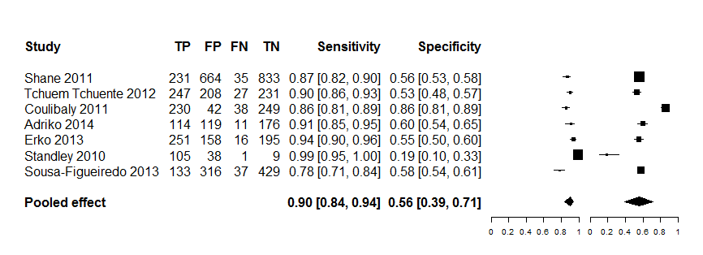

For POC-CCA, trace was considered as positive.
Kato-Katz consisted of single stool with duplicate slides (41.7mg of stool sample each).
Data points for Shane 2011, Tchuem Tchuente 2012 and Erko 2013 were extracted from Colley et al. 2013 that reported primary data from a multi-country study in Africa.
Analysing based on a summary of ROC from sensitivity versus false positive rate (1-specificity) of the test resulted in diagnostic accuracy measured by area under curve (AUC) of 0.86 (Model 1). Similar to the results of the forest plot in Analysis 1, clearly, there is wide variation in 1-specificity (false positive rate) of POC-CCA for detecting S. mansoni infection as depicted by the individual eclipses under the ROC space.

Model 1: Diagnostic accuracy of single POC-CCA versus Kato-Katz reference standard for the detection of S. mansoni infection from SROC curve
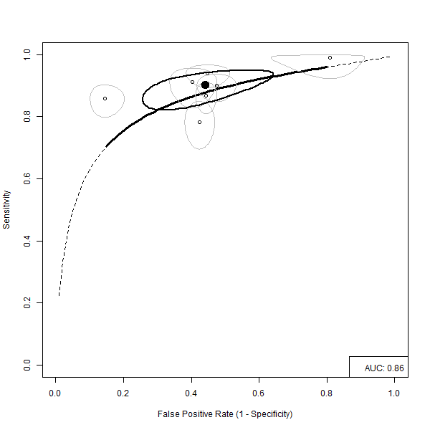
For POC-CCA, trace was considered as positive.
Kato-Katz consisted of single stool with duplicate slides (41.7mg of stool sample each).Data points for Shane 2011, Tchuem Tchuente 2012 and Erko 2013 were extracted from Colley et al. 2013 that reported primary data from a multi-country study in Africa

Explaining the SROC curve using Model 1 as an example
The SROC curves presented here are information rich, and contain a number of graphical features that each needs to be understood. The graph contains six separate types of information, represented by six separate types of graphical feature.
Hollow circles represent the point estimates for the joint sensitivity and specificity of each individual study. Each of these hollow circles is surrounded by a light grey oval, which presents the 95% credible region associated with that particular study in ROC space. Similarly, the summary models, produced by pooling the estimates from each of the studies using a standard bivariate model, are presented both as a point estimate, represented by a solid black circle, and an associated 95% credible region, represented by the solid black line. In addition to this, the best estimate for how the sensitivity and specificity vary with the diagnostic threshold adopted is represented by a line which runs from the bottom left to the top right portion of the graph. The solid section of this line represents interpolated estimates, which ‘fill in the gaps’ between the studies available, whereas the dashed parts of this line are extrapolated from the data, and as such are more dependent on the modelling assumptions. Both the interpolated and the extrapolated parts of this line are needed in order to estimate the area under the curve (AUC), which is defined in the bottom right hand corner of the graph.
2. SINGLE POC-CCA TEST VERSUS KATO-KATZ REFERENCE
The performance of single POC-CCA test was compared with Kato-Katz test from three consecutive stools (41.7 mg duplicate) for the detection of S. mansoni infection. Fourteen studies (Colulibaly 2011-study 1, Coulibaly 2011-study 2, Coulibaly 2011-study 3, Dawson 2013, Erko 2013, Legesse 2008, Tchuem Tchuente 2012-study 1, Tchuem Tchuente 2012-study 2, Tchuem Tchuente 2012-study 3, Koukounari 2013-study 1, Koukounari 2013-study 2, Legesse 2007, Coulibaly 2013, Adriko 2014), all from Africa, investigated this and showed pooled sensitivity of 0.85, 95% CI 0.80 to 0.88) and pooled specificity (0.66, 95% CI 0.54 to 0.76). Confidence intervals of some of the studies were wide reflecting small sample sizes. Whilst sensitiity estimates showed some consistency, there was huge variation in specificity in POC-CCA test.
Analysis 2: Single POC-CCA test versus three Kato-Katz test for the detection of S. mansoni infection.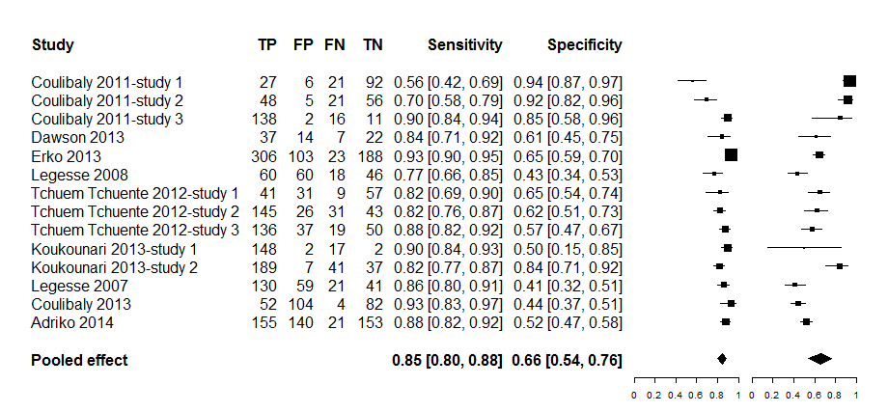
Kato-Katz consisted three consecutive stools of duplicate slides each of 41.7 mg
Dawson (2013) used Kato-Katz from two consecutive stools
Legesse 2007 and Legesse 2008 used an older version of POC-CCA reagent strips () with combined Kato-Katz and Formal Ether concentration test as reference standard
All other studies used POC-CCA cassette test (manufacturer: Rapid Medical Diagnostics, Pretoria, South Africa)
Koukounari 2013-study 1 and Koukounari 2013-study 2 involved separate data for children (7-16 years) and adults (≥ 17 years) so we reported tem separately as data independent studies in the analysis
From SROC curve involving the fourteen studies from Analysis 1, the overall sensitivity in the detection of S. mansoni infection was fairly consistent except two studies that appear to show some degree of variation. On the other hand, there appears to a considerable variation in false positive rate by POC-CCA in the detection of S. mansoni infection as seen from the eclipses spreading across from left to right of the ROC space (Model 2). The overall accuracy of POC-CCA from AUC is estimated to be 0.85.

Model 2: SROC curve of single POC-CCA test versus three Kato-Katz tests as reference standard
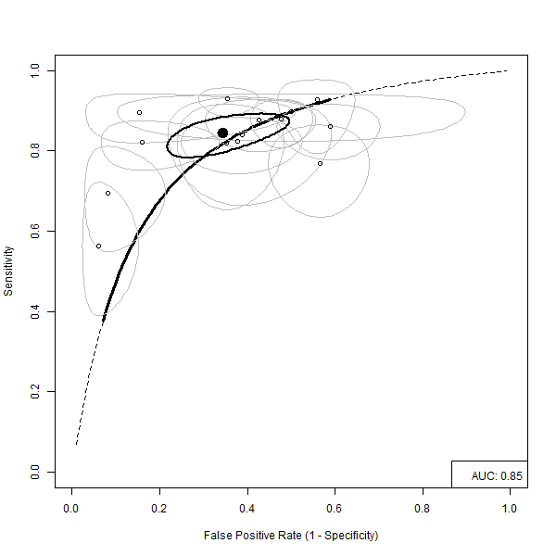

Kato-Katz consisted three consecutive stools of duplicate slides (41.7 mg each)
Dawson (2013) used Kato-Katz from two consecutive stools
Legesse 2007 and Legesse 2008 used an older version of POC-CCA reagent strips (manufactured by European Vertinary Laboratory, Woerden, Holland) with combined Kato-Katz and Formal Ether concentration test as reference standard
All other studies used POC-CCA cassette test (manufacturer: Rapid Medical Diagnostics, Pretoria, South Africa)
Koukounari 2013-study 1 and Koukounari 2013-study 2 involved separate data for children (7-16 years) and adults (≥ 17 years) so we reported tem separately as data independent studies in the analysis
3. THREE POC-CCA VS THREE KATO-KATZ
Eight studies, four from the same author from Cote d’Ivoire (Coulibaly 2011-study 1, Coulibaly 2011-study 2, Coulibaly 2011-study 3, Coulibaly 2013), three from the same author from Cameroon (Tchuem Tchuente 2012-study 1, Tchuem Tchuente 2012-study 2, Tchuem Tchuente 2012-study 3) and one from Ethiopia (Erko 2013) assessed the performance of three POC-CCA tests versus Kato-Katz tests from three consecutive stools (duplicate 41.7 mg) for the detection of S. mansoni infection. The meta-analysis showed pooled sensitivity of POC-CCA to be 0.91 [95% CI 0.84 to 0.95] and specificity 0.56 [95% CI 0.39 to 0.72] (Analysis 3). Sensitivity showed to be fairly consistent across studies but pooled specificity has wide confidence interval and a degree of variability across studies.

Analysis 3: Comparison of three POC-CCA tests with Kato-Katz from three consecutive stools for the detection of S. mansoni infection.
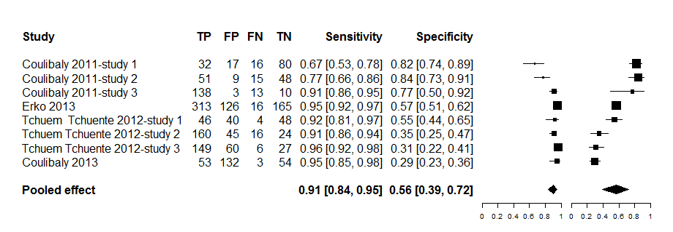

Coulibaly 2013 used duplicate instead of three POC-CCA cassette tests, the rest of the studies assessed three POC-CCA tests.
Coulibaly 2013 also used two consecutive stools for Kato-Katz tests, the rest of the studies used three consecutive stools.
For POC-CCA test, trace was considered as positive test

The summary Receiver Operator Characteristics produced an AUC of 0.86 (Model 3), but there appears to be a considerable variation across studies in terms specificity as depicted under the ROC space.

Model 3: Summary Receiver Operating Characteristics for the performance POC-CCA from three consecutive urine tests versus Kato-Katz from three consecutive stools, for the detection of S. mansoni infection
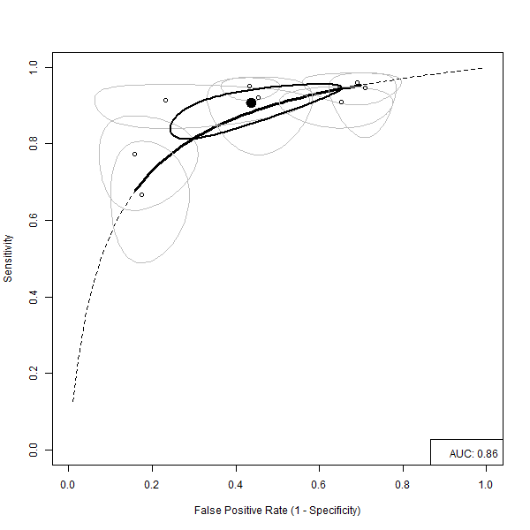

Coulibaly 2013 used duplicate instead of three POC-CCA cassettes, the rest of the studies assessed three POC-CCA tests.
Coulibaly 2013 also used two consecutive stools for Kato-Katz tests, the rest of the studies used three consecutive stools.
For POC-CCA test, trace was considered as positive test

4: POC-CCA REAGENT STRIP TEST VERSUS 10 ML URINE FILTRATION STANDARD REFERENCE
The performance of POC-CCA was assessed for the detection of S. haematobium infection in two locations in Ethiopia and Zimbabwe with mixed results, but pooling involved only two studies (Analysis 4). POC-CCA achieved a pooled sensitivity of 0.66 [95% CI 0.37 to 0.87] and specificity 0.54 [95% CI 0.34 to 0.73] with wide confidence intervals around the pooled estimates. The evidence appears to conflict as the study in Zimbabwe (Midzi 2009) produced a reasonably higher sensitivity (0.79, 95% CI 0.70 to 0.85) but the study in Ethiopia (Ayele 2008) showed very low sensitivity (0.52, 95% CI 0.42 to 0.62). Specificity from the individual studies also appears to be variable, very low in Zimbabwe (0.44, 95% CI 0.37 to 0.52) but relatively higher specificity from Ethiopia (0.64, 95% CI 0.54 to 0.72). The studies were conducted before 2007 and used relatively older version of CCA (develped by the European Vertinary Laboratory, Woerden, Holland).
In the study from Zimbabwe (Midzi 2009), the authors decided to create a parasitological gold standard reference from combined POC-CCA and standard urine filtration to assess the accuracy of POC-CCA and the results showed an improvement in sensitivity of POC-CCA by about 10% from 0.79% to 88.2%.

Analysis 4: Performance of POC-CCA strips versus standard 10 mL urine filtration for the diagnosis of urinary schistosomiasis
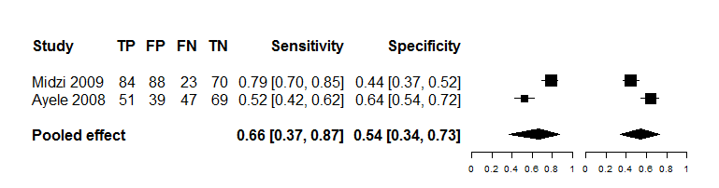

POC-CCA reagent strips based on van Dam 2004 with trace counted as positive test

The accuracy of POC-CCA was also assessed from SROC curve and the results show low performanace demonstraable with AUC from the ROC curve estimated to be 0.62 (Model 4).
Model 4: Performance of POC-CCA strips versus standard 10 mL urine filtration for the diagnosis of urinary schistosomiasis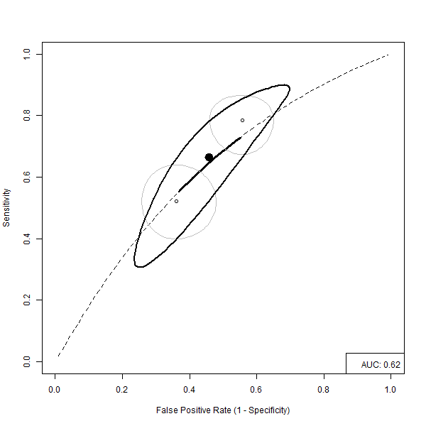
POC-CCA reagent strips based on van Dam 2004 with trace counted as positive test

5. COMPARISON BETWEEN POC-CCA AND KATO-KATZ
Nineteen studies were combined in the meta-analysis for the assessment of single and multiple POC-CCA (up to three tests) versus single and multiple Kato-Katz (up to three tests) for the diagnosis of S. mansoni infection and the results showed pooled sensitivity and specificity of 0.85 [95% CI 0.80 to 0.88] and 0.60 [95% CI 0.50 to 0.69], respectively. Confidence intervals of most of the study estimates are wide reflecting possible small sample sizes. The plot shows sensitivity to be fairly consistent across studies, but specificity appears to show a considerable degree of variability across the studies (Analysis 5).

Model 5: Assessment of diagnostic accuracy between single and multiple POC-CCA and single and multiple Kato-Katz tests for the diagnosis of S. mansoni infection
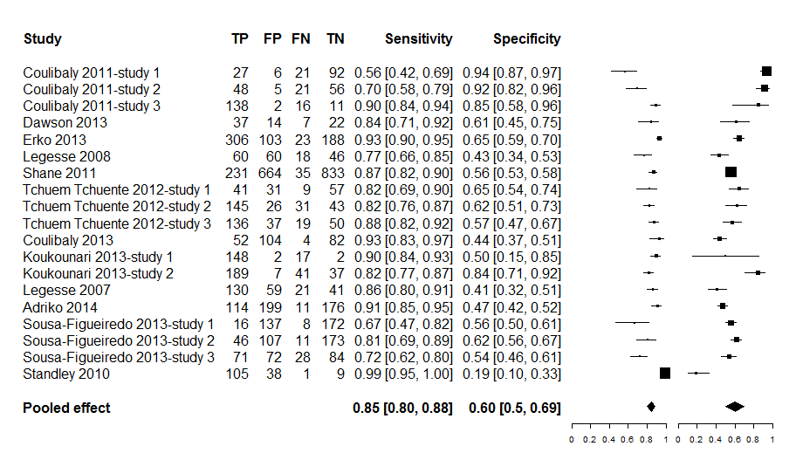

Studies included in this analysis had both index and reference tests examined in the same participants at the same time
Where a study assessed single, two, or three POC-CCA, the results of the single POC-CCA was. Single POC-CCA test were chosen for the analysis from Erko 2013 and Tchuem Tchuente 2012 study1; Tchuem Tchuente 2012 study 2; Tchuem Tchuente 2012 study3
For POC-CCA test, trace was considered as positive
Where a study assessed single, two or three Kato-Katz, single Kato-Katz (duplicate 41.7 mg) was chosen as reference standard in conformity with what WHO recommends within the MDA/PCT Strategy. Single Kato-Katz was chosen for the analysis from Erko 2013
If different settings were involved in a study published as one article but reported results for the separate settings, the different settings were included as separate data points. Coulibaly 2011 was classified as Coulibaly 2011 -study 1; Coulibaly 2011 -study 2; Coulibaly 2011 -study 3 and Tchuem Tchuente 2012 as Tchuem Tchuente 2012 -study 1; Tchuem Tchuente 2012 -study 2; Tchuem Tchuente 2012 -study 3)
Children and adults data reported separately were considered as separate datapoints in this analysis (Koukounari 2013)

The global assessment of POC-CCA test accuracy for the diagnosis of S. mansoni infection by ROC model shows variable performance. The AUC representing the overall accuracy of the test is 0.82, but the data demonstrate heterogeneity as shown on the SROC space with the degree of variability relatively higher for specificity (Model 5).

Model 5: Performance of single and multiple POC-CCA compared with single and multiple Kato-Katz tests for the diagnosis of S. mansoni infection
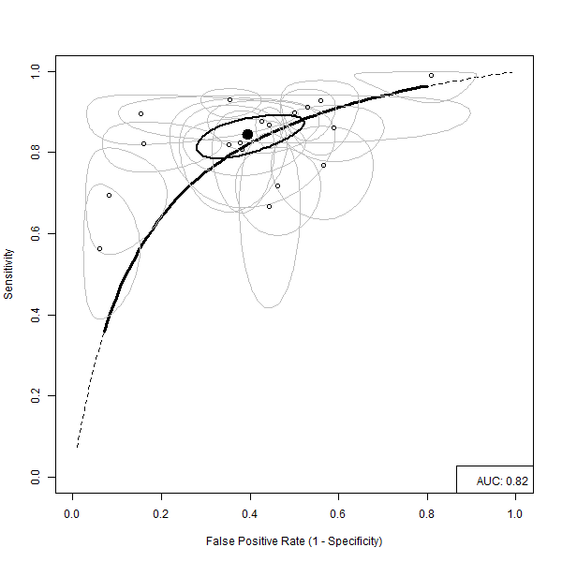
Studies included in this analysis had both index and reference tests examined in the same participants at the same time
Where a study assessed single, two, or three POC-CCA, the results of the single POC-CCA was. Single POC-CCA test were chosen for the analysis from Erko 2013 and Tchuem Tchuente 2012 study1; Tchuem Tchuente 2012 study 2; Tchuem Tchuente 2012 study3
For POC-CCA test, trace was considered as positive
Where a study assessed single, two or three Kato-Katz, single Kato-Katz (duplicate 41.7 mg) was chosen as reference standard in conformity with what WHO recommends within the MDA/PCT Strategy. Single Kato-Katz was chosen for the analysis from Erko 2013
If different settings were involved in a study published as one article but reported results for the separate settings, the different settings were included as separate data points. Coulibaly 2011 was classified as Coulibaly 2011 -study 1; Coulibaly 2011 -study 2; Coulibaly 2011 -study 3 and Tchuem Tchuente 2012 as Tchuem Tchuente 2012 -study 1; Tchuem Tchuente 2012 -study 2; Tchuem Tchuente 2012 -study 3)
Children and adults data reported separately were considered as separate datapoints in this analysis (Koukounari 2013)

6: ASSESSMENT OF POC-CCA BY BACKGROUND ENDEMICITY

a) Low endemicity
Four studies (Adriko 2014, Sousa-Figueiredo 2013, Tchuem Tchuente 2012, Coulibaly 2011) assessed the effect of low endemicity on diagnostic performance of POC-CCA. After combining the studies in a meta-analysis, the pooled sensitivity of POC-CCA was 0.69 [95% CI 0.56 to 0.79] lower than specificity 0.78 [95% CI 0.54 to 0.91] (Analysis 6). The confidence intervals of the pooled sensitivity and specificity are somehow wide, particularly for specificity.

Analysis 6a: Performance of POC-CCA in low endemicity settings for the detection of S. mansoni infection
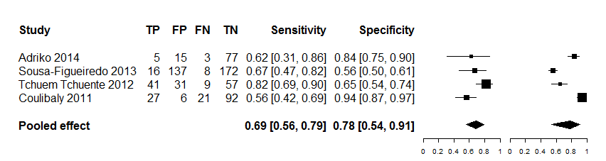
Kato-Katz was used as the reference standard
Low endemicity was defined based on WHO classification

The effect of low endemicity was also analysed from four studies using ROC curve and showed variation, particularly in sensitivity of the test in the ROC space (Model 6a). The diagnostic accuracy as measured by AUC under the ROC space was estimated to be 0.76.

Model 6a: SROC curve of accuracy of POC-CCA for the detection of S. mansoni infection in low endemicity settings with standard Kato-Katz as reference standard
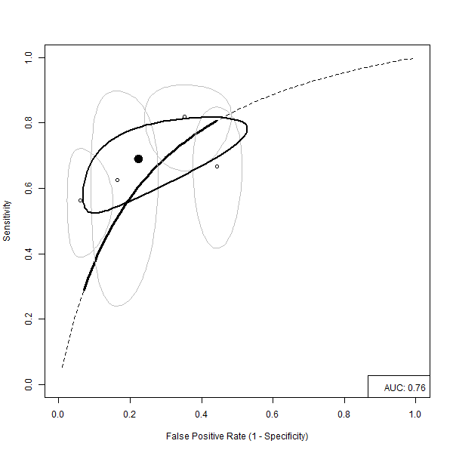
b) Moderate to high endemicity
The four studies that assessed the effect of low endemicity on diagnostic performance of POC-CCA (Adriko 2014, Sousa-Figueiredo 2013, Tchuem Tchuente 2012, Coulibaly 2011) assessed effect of moderate to high endemicity on POC-CCA performance. The results show pooled sensitivity of 0.81 [95% CI 0.76 to 0.85] and specificity of 0.74 [95% CI 0.55 to 0.87]. Pooled sensitivity is high and consistent across studies but specificity shows some variation and somehow wide confidence interval around the pooled estimate (Analysis 6b).

Analysis 6b: Performance of POC-CCA for the detection of S. mansoni infection in moderate to high endemicity settings using Kato-Katz reference standard
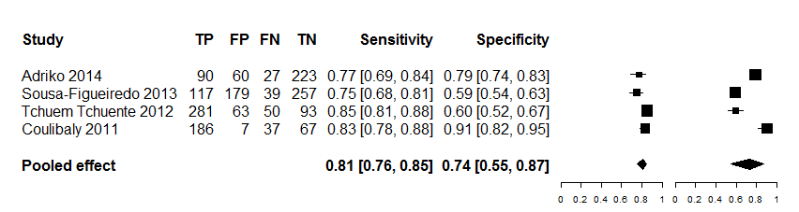

The effect of moderate to high endemicity was analysed from four studies (Adriko 2014, Sousa-Figueiredo 2013, Tchuem Tchuente 2012, Coulibaly 2011) and although there appears to be some variation across studies, this is higher for specificity than sensitivity (Model 6b). The diagnostic accuracy as measured by AUC under the ROC space is high (0.76).

Model 6b: SROC of POC-CCA for the detection of S. mansoni infection in moderate to high endemicity settings with standard Kato-Katz as reference standard
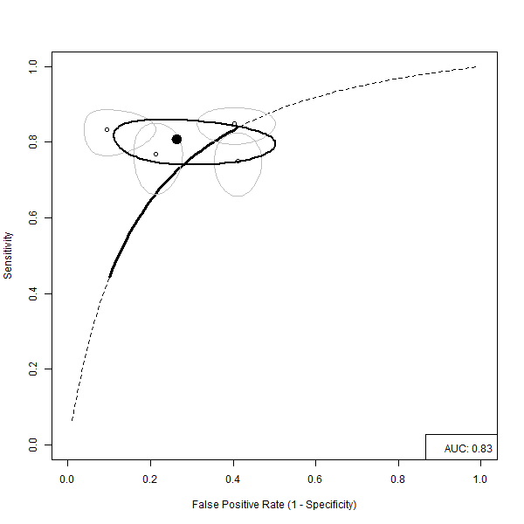

7. ASSESSMENT OF THRESHOLD EFFECT OF POC-CCA

7a) POC-CCA trace as positive versus Kato-Katz reference standard
The four studies conducted between 2009 and 2011, two from Uganda (Adriko 2014, Sousa-Figueiredo 2013), one from a village along the Lake Victoria shoreline of the Tanzanian-Kenyan border (Standley 2010) and one study from Cote d’Ivoire (Coulibaly 2013) assessed the impact of considering trace of POC-CCA test as positive on the diagnosis of S. mansoni infection (Analysis 7a). The combined studies showed an overall high sensitivity (0.93, 95% CI 0.74 to 0.99) of the POC-CCA test but very low specificity (0.42, 95% CI 0.28 to 0.58). From the confidence intervals of the independent studies included in this analysis, except the study by Sousa-Figueiredo 2013, sensitivity appeared to be consistent across the studies. Although the overall pooled specificity was low, one study (Standley 2010) reported unusually low specificity (0.19, 95% CI 0.10 to 0.33), but this is not expected to have affected the magnitude of the overall specificity as the study contributed only small weight to the pooled estimate.

Analysis 7a: Assessment of POC-CCA trace as positive on the diagnosis of S. mansoni infection
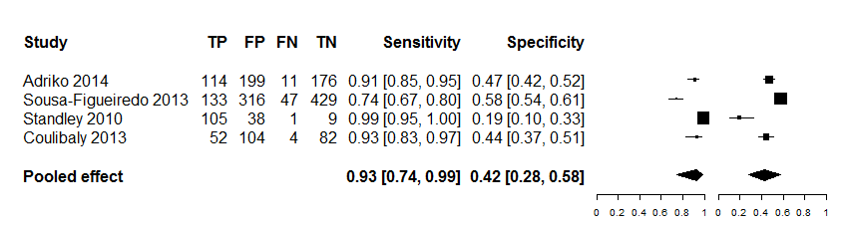

Adriko 2014, Sousa-Figueiredo 2013 and Standley 2010 assessed single POC-CCA versus Kato-Katz (41.7 mg duplicate) from a single stool
Coulibaly 2013 assessed two POC-CCA tests versus Kato-Katz (41.7 mg duplicate) from two consecutive stools

7a) POC-CCA trace as positive versus Kato-Katz reference standard

When the studies (Adriko 2014, Coulibaly 2013, Sousa-Figueiredo 2013, Standley 2010) were analysed using ROC curve that showed specificity from all the studies located to the right corner of the ROC space to suggest its low effect for the diagnosis of S. mansoni infection (Model 7a). The diagnostic accuracy as measured by AUC under the ROC space was low (0.66).

Model 7a: Summary ROC of POC-CCA for the detection of S. mansoni infection when trace is considered as positive
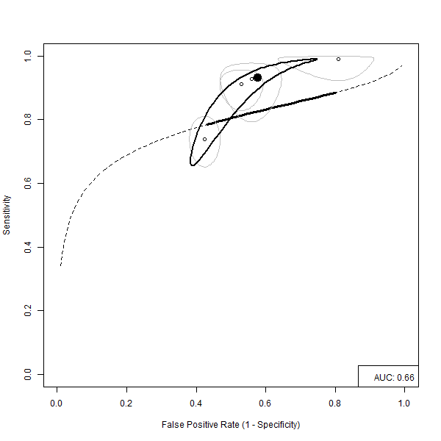

Adriko 2014, Sousa-Figueiredo 2013 and Standley 2010 assessed single POC-CCA versus Kato-Katz (41.7 mg duplicate) from a single stool
Coulibaly 2013 assessed two POC-CCA tests versus Kato-Katz (41.7 mg duplicate) from two consecutive stools

7b) POC-CCA trace as negative versus Kato-Katz reference standard
The four studies analysed in Figure 7a (Adriko 2014, Coulibaly 2013, Sousa-Figueiredo 2013, Standley 2010) also assessed the effect of counting trace of POC-CCA test as negative for the diagnosis of S. mansoni infection and showed lower pooled sensitivity (0.75, 95% CI 0.58 to 0.86) but improved specificity (0.79, 95% CI .073 to .085) compared to when trace is considered as positive (Analysis 7b). The confidence interval for the pooled sensitivity is somehow wide suggesting some degree of uncertainty in sensitivity when trace of POC-CCA test is considered as negative. The study from the Kenya-Tanzania shoreline district of Lake Victoria (Standley 2010) showed the biggest variation in both sensitivity and specificity.

Analysis 7b: Assessment of POC-CCA trace as negative on the diagnosis of S. mansoni infection
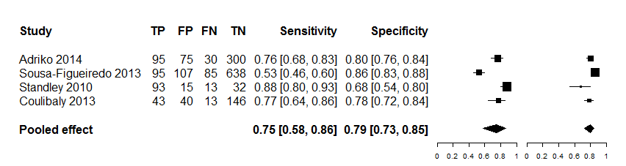

Adriko 2014, Sousa-Figueiredo 2013 and Standley 2010 assessed single POC-CCA versus Kato-Katz (41.7 mg duplicate) from a single stool
Coulibaly 2013 assessed two POC-CCA tests versus Kato-Katz (41.7 mg duplicate) from two consecutive stools

7b) POC-CCA trace as negative versus Kato-Katz reference standard

The studies (Adriko 2014, Coulibaly 2013, Sousa-Figueiredo 2013, Standley 2010) were further analysed using ROC curve and showed AUC under the ROC space of 0.84 (Model 7b).

Model 7b: Summary ROC of POC-CCA for the detection of S. mansoni infection when trace is
Considered as negative
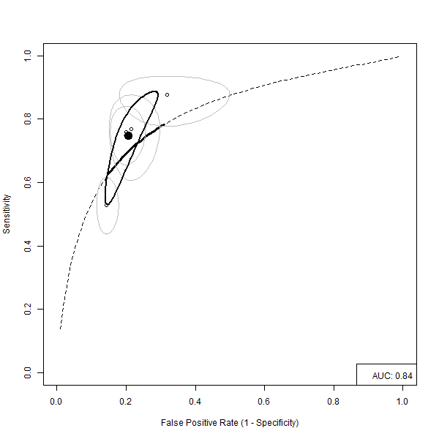

Adriko 2014, Sousa-Figueiredo 2013 and Standley 2010 assessed single POC-CCA versus Kato-Katz (41.7 mg duplicate) from a single stool
Coulibaly 2013 assessed two POC-CCA tests versus Kato-Katz (41.7 mg duplicate) from two consecutive stools

8. ASSESSMENT OF POC-CCA AGAINST A COMBINED GOLD STANDARD
Only one study (Erko 2013) has so far investigated index and standard reference, each against a combined ‘Gold standard’ reference for the diagnosis of S. mansoni infection. The standard Kato-Katz (single stool, 41.7 mg duplicate) was compared with a combined POC-CCA (three urines) plus Kato–Katz (three stools, 41.7 mg duplicate) Gold standard and showed a sensitivity of 51% and 100% specificity (Table 3). When Kato-Katz was increased to three stools (41.7 mg duplicate), sensitivity increased to 72% and specificity remained unchanged (100%). When a single POC-CCA was assessed against the combined POC-CCA plus Kato-Katz gold standard, sensitivity was high (90%) and no false positives were detected giving a specificity of 100%. When the number of POC-CCA was increased to three (ie based on three consecutive urines), sensitivity increased marginally by 6% to 96% and specificity remained unchanged (100%).

Table 3: POC-CCA or Kato-Katz versus combined POC-CCA and Kato–Katz as ‘Gold standard’ reference

 | Combined POC-CCA (three urines) and Kato–Katz (three stools, duplicate slides)
 |  |  | Positive | Negative | Sensitivity | Specificity | Study
Kato-Katz | Single | +ve | 231 | 0 | 51% | 100% | Erko 2013
Kato-Katz | Single | -ve | 224 | 165 | 51% | 100% | Erko 2013
Kato-Katz | Three | +ve | 329 | 0 | 72% | 100% | Erko 2013
Kato-Katz | Three | -ve | 126 | 165 | 72% | 100% | Erko 2013
POC-CCA* | Single | +ve | 409 | 0 | 90% | 100% | Erko 2013
POC-CCA* | Single | -ve | 46 | 165 | 90% | 100% | Erko 2013
POC-CCA* | Three | +ve | 439 | 0 | 96% | 100% | Erko 2013
POC-CCA* | Three | -ve | 16 | 165 | 96% | 100% | Erko 2013

*POC-CCA = Trace as +ve

9. EFFECT OF AGE ON POC-CCA
So far only one study (Koukounari 2013) has assessed the impact of age on POC-CCA accuracy for schistosome infections (Table 4). The study involved children aged 7-16 years and adults aged 17-76 years. The standard Kato-Katz (two stools, 41.7 mg duplicate) was used as reference standard. The results showed that sensitivity (82%) and specificity (84%) were high for adults. When it was assessed in children, sensitivity improved by about 8% to 90% but specificity decreased considerably to 50%. The results though came from only one study with limited sample size.
Table 4: Impact of age of participants on accuracy of POC-CCA test
 | Combined Kato–Katz (three stools, 6 slides) and CCA cassette (three urines) as gold standard
 |  |  | Positive | Negative | Sensitivity | Specificity | Study
POC-CCA | Adults | +ve | 189 | 7 | 82% | 84% | Koukounari 2013
POC-CCA | Adults | -ve | 41 | 37 | 82% | 84% | Koukounari 2013
POC-CCA | Children | +ve | 148 | 2 | 90% | 50% | Koukounari 2013
POC-CCA | Children | -ve | 17 | 2 | 90% | 50% | Koukounari 2013

*POC-CCA = Trace as +ve
10. LATENT CLASS ANALYSIS
Two latent classes have been identified using AIC and BIC criteria with a substantial difference in specificity. Generally, the data showed substantial heterogeneity with POC-CA test classified in both class 1 and class 2, suggesting that the observed variation of test outcomes cannot be explained by threshold effect alone (Table 5). Latent Class 1 showed mean sensitivity of 83.4% 95% CI 81.1% to 85.7% and mean specificity of 82.9%, 95% CI 80.8% to 85.0%. Latent Class 2 shows mean sensitivity of 88.0%, 95% CI 86.8% to 89.2% and specificity of 46.3%, 95% CI 44.1% to 48.5%.

Table 5: classification of POC-CCA according to Latent Class Analysis

 | Mean Sensitivity | Mean Specificity
Class 1 | 86.1% | 93.8%
Class 2 | 83.0% | 55.6%

From subgroup analyses, number POC-CCA does not appear to affect sensitivity and specificity appreciably. Form the two classes, urine samples do not appear to be influenced by the global performance of the test in terms of sensitivity and specificity although studies in latent class 1 are likely to perform better. Urine samples do not appear to influence the global performance in terms of sensitivity and specificity.

Table 6: Cross-classification of different POC-CA tests in the two classes
 | Latent Class 1 | % | Latent Class 2 | %
POC-CCA cassette (one urine) | 19 | 35% | 36 | 65%
POC-CCA cassette (two urine) | 0 | 0% | 1 | 100%
POC-CCA cassette (three urine) | 3 | 50% | 3 | 50%
POC-CCA reagent strips | 1 | 20% | 4 | 80%

Sensitivity and specificity on the ROC space are demonstrated using LCA (Figure 8).

Figure 8: LCBM showing Latent Classes of POC-CCA test 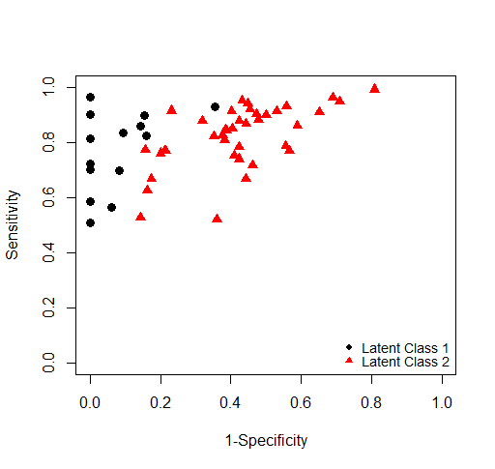

11. PATIENT ACCEPTABILITY OR PREFERENCE FOR POC-CCA
An overwhelming majority of participants stated that urine-based POC-CCA test was acceptable to them (21 of 28 studies, the remaining seven studies did not investigate this outcome). Still, there is paucity of comparative information on acceptability between POC-CCA and the traditional stool-based Kato-Katz in the diagnosis of S. mansoni infection (see Table 2: Characteristics of the included studies).

12. ASSESSMENT OF COST OF APPLICATION OF POC-CCA
There is paucity of reliable information on cost of the application of CCA and Kato-Katz. Only six studies reported cost information as part of their assessment (see Characteristics of the included studies) but their reliability could not be independently verified. One study (Stothard 2009) attempted to predict the cost of CCA in 2009 and showed that the cost of a single CCA dipstick ranged between US$2.6 and US$4.6 contingent upon numbers requested and that it did not include freight or local taxes. One study that made detailed cost assessment of Kato-Katz was investigating soil transmitted helminths (Speich 2010). The study estimated the cost of a single stool Kato-Katz thick smear (41.7 mg) to be US$1.73 and duplicate to be US$2.06. From the available data, the cost of using CCA for the diagnosis of a schistosome infection ranges between US$ 1.60 and US$4.95 compared to US$1.70-US$1.73 for Kato-Katz. However, there is no head-to-head comparison of cost between CCA and Kato-Katz tests.
Discussion
This systematic review assessed the diagnostic accuracy of urine-based POC-CCA cassette test for the diagnosis of schistosome infections using stool-based Kato-Katz thick smear (for S. mansoni and S. japonicum,) or standard 10 mL urine filtration (for S. haematobium) as reference standard. The key findings have been summarized here. Single POC-CCA showed to perform better than single Kato-Katz (41.7 mg duplicate): pooled sensitivity (0.90, 95% CI 0.84 to 0.94; seven studies) and specificity (0.56, 95% CI 0.54 to 0.61; seven studies) or Kato-Katz from duplicate of three consecutive stools. Strikingly, number of POC- CCA tests did not appear to influence accuracy whilst further analysis by LCBM showed only two latent classes of POC-CCA.

Although most of studies included in this systematic review and meta-analysis were conducted recently, mostly after the new millennium, the standards of methodological quality did not reach the high standards expected from current diagnostic studies. For example, none of the studies was a randomized control trial, all are cross-sectional studies. However, sensitivity is consistent across studies although specificity appears to be variable, it is unlikely that methodological quality will have caused such substantive biases to interfere with the evidence presented.

All the studies were conducted in Africa, the vast majority coming from East Africa. Twenty six studies assessed POC-CCA for the diagnosis of S. mansoni infection and two for S. haematobium infection. None assessed POC-CCA for the detection of S. japonicum infection. Also, the vast majority of the studies recruited young children (preschool and school aged children). The of uniformity across studies with regard to parameters assessed means that the extent to which the study conclusions are generalizable is unclear.

With the scale up of schistosomiasis treatment and control via MDA/PCT strategy, prevalence and intensity of infection have fallen significantly in most areas such that routinely used diagnostic tests are insensitive. The finding CCA performs better in high than low endemicity settings has both practice and control implications. However, the finding is may not be conclusive as it came from only one study. Further studies comparing the performance of POC-CCA in different endemicity settings are warranted.

The results showed that sensitivity and specificity improve when POC-CCA is assessed against a ‘parasitological gold standard’ (combined index test and reference standard). Some researchers have suggested that given the standard Kato-Katz from a single stool is particularly insensitive when infection levels are low usually after treatment (Utzinger 2001; Booth 2003). Therefore, to evaluate a new test in low endemicity setting requires multiple samples that would allow a reliable ‘parasitological gold standard’ to be created (Deelder 2012). Otherwise, the high percentage of false-negative egg counts may render any conclusions on the specificity of a new test unreliable. Given this limitation, it was expected that most studies would employ a combined gold standard from the index test and reference standard to allow a reliable assessment of the infection but of the studies included in this review, only two studies properly created parasitological gold standard (Midzi 2009; Erko 2013). The evidence on this comes from only one study and remains inconclusive. Therefore, well-designed studies are warrants to contribute more evidence.

Predictive values are mathematically dependent on the pre-test prevalence of the infection (Bossuyt 2013). Given that studies from different endemicity settings were combined in the meta-analysis, pooled sensitivity and specificty which are not affected much by background prevalence were mostly used for reporting accuracy or performance of a test. Nonetheless, sensitivity and specificity vary with threshold.

The absence of a clear reference standard creates an additional form of uncertainty in the meta-analysis of diagnostic data. For this reason a number of different analyses have been conducted in which different tests have been assumed to be the reference standard. The use of latent class analysis (LCA) is sometimes proposed as a statistical method which can be used for the meta-analysis of diagnostic data without a clear gold standard. However the application of this approach in this field is relatively limited and there are no standard models or accessible software tools which can be used to perform such analyses. Without the establishment of a standard way of using LCA in the context of diagnostic meta-analysis, and a clear understanding amongst those tasked with interpreting the results of the assumptions built into such models, the use of LCA may replacing an explicit form of uncertainty - the lack of a true reference standard - with a more implicit kind of uncertainty about the appropriateness of the model assumptions. Despite these concerns, we have contacted the authors of a recent paper describing a LCA model and hope to be able to have the results of using this model available at a later date. The LCA model is currently not accessible, only implemented in an expensive commercial software packages Latent GOLD, and not easy to implement in any freely available or accessible software. It should be stressed that, because the bivariate models are somewhat more established in meta-analysis, and because the explicit uncertainty involved in choosing from a range of imperfect reference standards is easier to understand than the implicit uncertainty about the LCA modelling assumptions, any results based on using an LCA model should be considered secondary and supplementary to those produced using the bivariate models.

Therefore, we investigated latent class through Latent Class Bivariate Analysis that identified two latent classes using AIC and BIC criteria that demonstrated a substantial difference in specificity. Subgroup analyses were needed and the results show that number of urine samples for the test do not affect sensitivity and specificity in POC-CA appreciably. Given that the two latent classes identified show a major difference in terms of specificity, variation in test outcomes cannot be explained by threshold effect alone. Further exploratory analysis involving compilation of studies based on the identified latent classes to relate to background factors but again number of urines, year the study was conducted and geographic location do not appear to affect accuracy. Age and endemicity could not be thoroughly explored at this stage warranting further studies.

Although there are limitations in the studies includes in the review, the evidence is presented appears to be strong and consistent across studies. All the studies were based on fully paired (within-study) comparative accuracy studies and this review addressed a well-defined question in terms of participants, interventions, outcomes, and study design. The search included relevant electronic databases, and attempts were made to retrieve unpublished studies. Bias and errors were minimised during the review process with two reviewers independently selecting studies and extracting data, and presenting characteristics of the individual studies. Potential sources of heterogeneity were explored and reported. The conclusions are consistent with the set objectives and evidence shown and are likely to be reliable.

Conclusions
Single POC-CCA appears to perform better than Kato-Katz from a single stool or Kato-Katz from three consecutive stools for the detection of S. mansoni infection based on the reported meta-analysis estimates. Three POC-CCA tests do not appear to be superior or have any demonstrable incremental advantage over single POC-CCA test for the diagnosis of S. mansoni infection. POC-CCA test appears much more variable for the diagnosis of S. haematobium infection.
No conflict of interest declared any of the authors.

References

Included studies
1. Adriko M, Standley CJ, Tinkitina B, Tukahebwa EM, Fenwick A, Fleming FM, Sousa-Figueiredo JC, Stothard JR⁷, Kabatereine NB⁸. Evaluation of circulating cathodic antigen (CCA) urine-cassette assay as a survey tool for Schistosoma mansoni in different transmission settings within Bugiri District, Uganda. Acta Trop. 2014. pii: S0001-706X(14)00114-4.
2. Ayele B, Erko B, Legesse M, Hailu A, Medhin G. Evaluation of circulating cathodic antigen (CCA) strip for diagnosis of urinary schistosomiasis in Hassoba school children, Afar, Ethiopia. Parasite. 2008, 15(1):69-75.
3. Colley DG, Binder S, Campbell C, King CH, Tchuem Tchuenté LA, N'Goran EK, Erko B, Karanja DM, Kabatereine NB, van Lieshout L, Rathbun S. A five-country evaluation of a point-of-care circulating cathodic antigen urine assay for the prevalence of Schistosoma mansoni. Am J Trop Med Hyg. 2013, 88(3):426-32.
4. Coulibaly JT, N'Gbesso YK, Knopp S, N'Guessan NA, Silué KD, van Dam GJ, N'Goran EK, Utzinger J. Accuracy of urine circulating cathodic antigen test for the diagnosis of Schistosoma mansoni in preschool-aged children before and after treatment. PLoS Negl Trop Dis. 2013, 7(3):e2109.
5. Coulibaly JT1, Knopp S, N'Guessan NA, Silué KD, Fürst T, Lohourignon LK, Brou JK, N'Gbesso YK, Vounatsou P, N'Goran EK, Utzinger J. Accuracy of urine circulating cathodic antigen (CCA) test for Schistosoma mansoni diagnosis in different settings of Côte d'Ivoire. PLoS Negl Trop Dis. 2011, 5(11):e1384. doi: 10.1371/journal.pntd.0001384.
6. Dawson EM, Sousa-Figueiredo JC, Kabatereine NB, Doenhoff MJ, Stothard JR. Intestinal schistosomiasis in pre school-aged children of Lake Albert, Uganda: diagnostic accuracy of a rapid test for detection of anti-schistosome antibodies. Trans R Soc Trop Med Hyg. 2013, 107(10):639-47.
7. De Clercq D, Sacko M, Vercruysse J, vanden Bussche V, Landouré A, Diarra A, Gryseels B, Deelder A. Assessment of cure by detection of circulating antigens in serum and urine, following schistosomiasis mass treatment in two villages of the Office du Niger, Mali. Acta Trop. 1997, 68(3):339-46.
8. De Clercq D, Sacko M, Vercruysse J, vanden Bussche V, Landouré A, Diarra A, Gryseels B, Deelder A Assessment of cure by detection of circulating antigens in serum and urine, following schistosomiasis mass treatment in two villages of the Office du Niger, Mali. Acta Trop. 1997, 68(3):339-46.
9. Erko B, Medhin G, Teklehaymanot T, Degarege A, Legesse M. Evaluation of urine-circulating cathodic antigen (Urine-CCA) cassette test for the detection of Schistosoma mansoni infection in areas of moderate prevalence in Ethiopia. Trop Med Int Health. 2013, 18(8): 1029–1035.
10. Koukounari A, Donnelly CA, Moustaki I, Tukahebwa EM, Kabatereine NB, Wilson S, Webster JP, Deelder AM, Vennervald BJ, van Dam GJ. A latent markov modelling approach to the evaluation of circulating cathodic antigen strips for schistosomiasis diagnosis pre- and post-praziquantel treatment in Uganda. PLoS Comput Biol. 2013, 9(12):e1003402.
11. Kremsner PG, Enyong P, Krijger FW, De Jonge N, Zotter GM, Thalhammer F, Mühlschlegel F, Bienzle U, Feldmeier H, Deelder AM. Circulating anodic and cathodic antigen in serum and urine from Schistosoma haematobium-infected Cameroonian children receiving praziquantel: a longitudinal study. Clin Infect Dis. 1994, 18(3):408-13.
12. Legesse M, Erko B. Field-based evaluation of a reagent strip test for diagnosis of schistosomiasis mansoni by detecting circulating cathodic antigen (CCA) in urine in low endemic area in Ethiopia. Parasite. 2008, 15(2):151-5.
13. Legesse M, Erko B. Field-based evaluation of a reagent strip test for diagnosis of Schistosoma mansoni by detecting circulating cathodic antigen in urine before and after chemotherapy. Trans R Soc Trop Med Hyg. 2007, 101(7):668-73.
14. Midzi N, Butterworth AE, Mduluza T, Munyati S, Deelder AM, van Dam GJ. Use of circulating cathodic antigen strips for the diagnosis of urinary schistosomiasis. Trans R Soc Trop Med Hyg. 2009, 103(1):45-51.
15. Shane HL, Verani JR, Abudho B, Montgomery SP, Blackstock AJ, et al. Evaluation of Urine CCA Assays for Detection of Schistosoma mansoni Infection in Western Kenya. PLoS Negl Trop Dis. 2011, 5(1): e951.
16. Sousa-Figueiredo JC, Betson M, Kabatereine NB, Stothard JR. The urine circulating cathodic antigen (CCA) dipstick: a valid substitute for microscopy for mapping and point-of-care diagnosis of intestinal schistosomiasis. PLoS Negl Trop Dis. 2013, 7(1):e2008.
17. Sousa-Figueiredoa JC, Pleasant J, Day M, Betson M, Rollinsona D, Montresor A, Kazibwe F, Kabatereine NB, Stothard JR. Treatment of intestinal schistosomiasis in Ugandan preschool children: best diagnosis, treatment efficacy and side-effects, and an extended praziquantel dosing pole. International Health 2010, 103–113.
18. Speich B, Knopp S, Mohammed KA, Khamis IS, Rinaldi L, Cringoli G, Rollinson D, Utzinger J. Comparative cost assessment of the Kato-Katz and FLOTAC techniques for soil-transmitted helminth diagnosis in epidemiological surveys. Parasit Vectors. 2010. 14;3:71. doi: 10.1186/1756-3305-3-71.
19. Standley CJ, Lwambo, NJS Lange CN, Kariuki HC, Adriko M, Stothard JR. Performance of circulating cathodic antigen (CCA) urine-dipsticks for rapid detection of intestinal schistosomiasis in schoolchildren from shoreline communities of Lake Victoria. Parasites & Vectors 2010, 3:7. doi:10.1186/1756-3305-3-7.
20. Stothard JR. Improving control of African schistosomiasis: towards effective use of rapid diagnostic tests within an appropriate disease surveillance model. Trans R Soc Trop Med Hyg. 2009, 103(4):325-32.
21. Tchuem Tchuente´ L-A, Kuete´ Fouodo CJ, Kamwa Ngassam RI, Sumo L, Dongmo Noumedem C, et al. Evaluation of Circulating Cathodic Antigen (CCA) Urine-Tests for Diagnosis of Schistosoma mansoni Infection in Cameroon. PLoS Negl Trop Dis. 2012, 6(7): e1758.

Other references

Allan RW. The Johns Hopkins Hospital, Department of Pathology. Johns Hopkins Microbiology Newsletter 2001;20:30.
Berggren WL, WellerTH. Immunoelectrophoretic demonstration of specific circulating antigen in animals infected with Schistosoma mansoni. American Journal of Tropical Medicine and Hygiene. 1967. 23; 1077-1084.
Bergquist R, Johansen MV, Utzinger J. Diagnostic dilemmas in helminthology: what tools to use and when?. Trends in Parasitology 2009;25(4):151-6.
Bogoch II, Andrews JR, Dadzie ERK, Utzinger J. Simple questionnaire and urine reagent strips compared to microscopy for the diagnosis of Schistosoma haematobium in a community in northern Ghana. Trop Med Int Health. 2012;17(10):1217-21.
Booth M, Vounatsou P, N'Goran EK, Tanner M, Utzinger J. The influence of sampling effort and the performance of the Kato-Katz technique in diagnosing Schistosoma mansoni and hookworm co-infections in rural Côte d'Ivoire. Parasitology 2003;127(Pt 6):525-31.
Borenstein M, Hedges LV, Higgins JPT, Rothstein HR. Introduction to Meta-Analysis 2009. A John Wiley and Sons, Ltd., Publication. John Wiley & Sons Ltd, Chichester, West Sussex, UK
Bosompem, K. M., Ayi, I., Anyan, W. K., Nkrumah F. K. and Kojima S. (1996a). Limited field evaluation of a rapid monoclonal antibody-based dipstick assay for urinary schistosomiasis. Hybridoma. 15, 443-447.
Bosompem, K. M., Arishima, T., Yamashita, T., Ayi I., Anyan, W. K. and Kojima, S. (1996b). Extraction of Schistosoma haematobium antigens from infected human urine and generation of potential diagnostic monoclonal antibodies to urinary antigens. Acta. Trop. 62, 91-103.
Bosompem K.M,. Asigbee J.R.K,. Otchere J., Haruna A., Kpo H. K., and. Kojima S: Accuracy of diagnosis of urinary schistosomiasis: comparison of parasitological and a monoclonal antibody-based dipstick. (1998) Parasitology International 47 211-217.
Bossuyt P, Davenport C, Deeks J, Hyde C, Leeflang M, Scholten R. Chapter 11:Interpreting results and drawing conclusions. In: Deeks JJ, Bossuyt PM, Gatsonis C (editors), Cochrane Handbook for Systematic Reviews of Diagnostic Test Accuracy Version 0.9. The Cochrane Collaboration, 2013. Available from: http://srdta.cochrane.org/.
Braun-Munzinger RA, Southgate BA. Repeatability and reproducibility of egg counts of Schistosoma haematobium in urine. Tropical Medicine and Parasitology 1992;43(3):149-54.
Brooker S, Kabatereine NB, Gyapong JO, Stothard JR, Utzinger J. Rapid mapping of schistosomiasis and other neglected tropical diseases in the context of integrated control programmes in Africa. Parasitology. 2009;136(13):1707-18.
Brooker S, Hotez PJ, Bundy DA. The global atlas of helminth infection: mapping the way forward in neglected tropical disease control. PLoS Negl Trop Dis. 2010;4(7):e779.
Chalmers I. The lethal consequences of failing to make use of all relevant evidence about the effects of medical treatments: the need for systematic reviews. In P. Rothwell (ed.). Treating Individuals, ed. London: Lancet 2007:37-58.
Chitsulo L, Engels D, Montresor A, Savioli L. The global status of schistosomiasis and its control. Acta Tropica, 2000, 77:41–51.
Cioli D, Pica-Mattoccia L, Archer S. Antischistosomal drugs: past, present . . . and future? Pharmac. 1995;68:35–85.
Cnops L, Tannich E, Polman K, Clerinx J, Van Esbroeck M. Schistosoma real-time PCR as diagnostic tool for international travellers and migrants. Trop Med Int Health. 2012;17(10):1208-16.
Danso-Appiah A, Stolk WA, Bosompem KM, Otchere J, Looman CW et al. Health seeking behaviour and utilization of health facilities for schistosomiasis-related symptoms in ghana. PLoS Negl Trop Dis. 2010;4(11):e867. doi: 10.1371/journal.pntd.0000867.
Danso-Appiah A, De Vlas SJ, Bosompem KM, Habbema JD. Determinants of health-seeking behaviour for schistosomiasis-related symptoms in the context of integrating schistosomiasis control within the regular health services in Ghana. Trop Med Int Health. 2004;9(7):784-94.
De Jonge N, Fillie YE, Hilberath GW et al. (1989) Presence of the schistosome circulating anodic antigen (CAA) in urine of patients with Schistosoma mansoni or S. haematobium infections. American Journal of Tropical Medicine and Hygiene 41,563–569.
De Jonge N, Gryseels B, Hilberath GW, Polderman, Deelder AM (1988) Detection of circulating anodic antigen by ELISA for seroepidemiology of schistosomiasis mansoni. Transactions of the Royal Society of Tropical Medicine and Hygiene 82,591–594.
De Vlas SJ, Gryseels B, Van Oortmarssen GJ, Polderman AM, Habbema JD (1992). A model for variations in single and repeated egg counts in Schistosoma mansoni infections. Parasitology. 104( Pt 3):451-60.
De Vlas SJ, Engels D, Rabello AL, Oostburg BF, Van Lieshout L, Polderman AM, Van Oortmarssen GJ, Habbema JD, Gryseels B (1997). Validation of a chart to estimate true Schistosoma mansoni prevalences from simple egg counts. Parasitology. 114 (Pt 2):113-21.
Deelder AM, van Dam GJ, van Lieshout L. Response to: accuracy of circulating cathodic antigen tests for rapid mapping of Schistosoma mansoni and S. haematobium infections in Southern Sudan by RA Ashton et al. (2011) Trop Med Int Health 16, pp. 1099-1103. Trop Med Int Health. 2012 Mar;17(3):402-3.
Deelder, A. M., Klappe, H J.M, Van den Aardweg, G.J M.J. and Van Meerbeke, E.H E M. (1976). Schistosoma mansoni: demonstration of two circulating antigens in infected hamsters. Experimental Parasitology, 40; 189-197.
Doebler P, Holling H, Böhning D. A mixed model approach to meta-analysis of diagnostic studies with binary test outcome. Psychol Methods [Internet]. 2012 Sep [cited 2014 Jul 12];17(3):418–36. Available from: http://www.ncbi.nlm.nih.gov/pubmed/22582866.
Doenhoff MJ, Chiodini PL, Hamilton JV. Specific and sensitive diagnosis of schistosome infection: can it be done with antibodies?. Trends in Parasitology 2004;20(1):35-9.
Egger M, Davey SG. Meta-analysis: potentials and promise. BMJ 1997;315: 1371-4.
Engels D, Sinzinkayo E, De Vlas SJ, Gryseels B. Intraspecimen fecal egg count variation in Schistosoma mansoni infection. American Journal of Tropical Medicine and Hygiene 1997;57(5):571-7.
Engels D, Sinzinkayo E, Gryseels B. Day-to-day egg count fluctuation in Schistosoma mansoni infection and its operational implications. American Journal of Tropical Medicine and Hygiene 1996;54(4):319-24.
Engels D, Chitsulo L, Montresor A, Savioli L. The global epidemiological situation of schistosomiasis and new approaches to control and research. Acta Trop. 2002;82(2):139-46.
Enk MJ, Silva OG, Rodrigues NB. Diagnostic accuracy and applicability of a PCR system for the detection of Schistosoma mansoni DNA in human urine samples from an endemic area. PLoS One. 2012;7(6):e38947. doi: 10.1371/journal.pone.0038947.
Enk MJ, Lima AC, Drummond SC, Schall VT, Coelho PM. The effect of the number of stool samples on the observed prevalence and the infection intensity with Schistosoma mansoni among a population in an area of low transmission. Acta Trop. 2008;108(2-3):222-8.
Eusebi P, Reitsma JB, Vermunt JK. Latent class bivariate model for the meta-analysis of diagnostic test accuracy studies. BMC Med Res Methodol. 2014;14(1):88. doi: 10.1186/1471-2288-14-88.
P Eusebi, JB Reitsma, JK Vermunt Latent class bivariate model for the meta-analysis of diagnostic test accuracy studies. BMC medical research methodology 14 (1), 88.
Fenwick A, Rollinson D, Southgate V. Implementation of human schistosomiasis control: Challenges and prospects. Adv Parasitology 2006;61:567–622.
Fenwick A, Webster JP, Bosque-Oliva E, Blair L, Fleming FM, Zhang Y, et al. The Schistosomiasis Control Initiative (SCI): rationale, development and implementation from 2002-2008. Parasitology 2009;136(13):1719-30.
French MD, Rollinson D, Basáñez MG, Mgeni AF, Khamis IS, Stothard JR.School-based control of urinary schistosomiasis on Zanzibar, Tanzania: monitoring micro-haematuria with reagent strips as a rapid urological assessment. J Pediatr Urol. 2007;3(5):364-8. doi: 10.1016/j.jpurol.2007.01.198.
Glinz D, Silué KD, Knopp S, Lohourignon LK, Yao KP et al. Comparing diagnostic accuracy of Kato-Katz, Koga agar plate, ether-concentration, and FLOTAC for Schistosoma mansoni and soil-transmitted helminths. PLoS Negl Trop Dis. 2010;4(7):e754. doi: 10.1371/journal.pntd.0000754.
Gold, R., Rosen, S. and Weller, T.H. (1969). A specific circulating antigen in hamsters infected with Schistosoma mansoni: detection of antigen in serum and urine and correlation between antigenic concentration and worm burden. American Journal of Tropical Medicine and Hygiene; 18: 545-550.
Gryseels B, Polman K, Clerinx J, Kestens L. Human schistosomiasis. Lancet. 2006;368(9541):1106-18.
Gryseels B, de Vlas SJ. Worm burdens in schistosome infections. Parasitology Today 1996;12(3):115-9.
Gryseels B, Polderman AM, Engels D. Experiences with the control of schistosomiasis mansoni in two foci in central Africa. Memorias do Instituto Oswaldo Cruz 1992;87(Suppl 4):187–94.
Gryseels B, Polderman AM. The morbidity of schistosomiasis mansoni in Maniema (Zaire). Trans R Soc Trop Med Hyg. 1987;81(2):202–9.
Harbord RM, Deeks JJ, Egger M, Whiting P, Sterne JAC. A unification of models for meta-analysis of diagnostic accuracy studies. Biostatistics [Internet]. 2007 Apr [cited 2014 Jul 27];8(2):239–51. Available from: http://www.ncbi.nlm.nih.gov/pubmed/16698768
Higgins JPT, Green S (editors). Cochrane Handbook for Systematic Reviews of Interventions Version 5.1.0 [updated March 2011]. The Cochrane Collaboration, 2011.
Hotez P. Enlarging the "Audacious Goal": elimination of the world's high prevalence neglected tropical diseases. Vaccine. 2011;29 Suppl 4:D104-10. doi: 10.1016/j.vaccine.2011.06.024.
Hotez PJ. Mass drug administration and integrated control for the world’s high-prevalence neglected tropical diseases. Clin Pharmacol Therap. 2009;85: 659–64.
Hotez PJ, Molyneux DH, Fenwick A, Ottesen E, Ehrlich Sachs S, Sachs JD. Incorporating a rapid-impact package for neglected tropical diseases with programs for HIV/AIDS, tuberculosis, and malaria. PLoS Med. 2006;3:e102.
Igreja RP, Matos JA, Gonçalves MM, Barreto MM, Peralta JM.Schistosoma mansoni-related morbidity in a low-prevalence area of Brazil: a comparison between egg excretors and seropositive non-excretors. Ann Trop Med Parasitol. 2007;101(7):575–84.
Katz N, Chaves A, Pellegrino J. A simple device for quantitative stool thick-smear technique in Schistosomiasis mansoni. Rev Inst Med Trop Sao Paulo. 1972;14(6):397-400.
Kelly C. 1987. Molecular studies of schistosome immunity. In: The Biology of Schistosomes; from genes to Latrines.
Khan K, Kunz R, Kleijnen J, Antes G. Systematic reviews to support evidence-based medicine. How to review and apply findings of healthcare research. second edition, 2011. Hodder Arnold, Hodder Education, a division of Hachette London.
King CH, Bertsch D. Meta-analysis of urine heme dipstick diagnosis of Schistosoma haematobium infection, including low-prevalence and previously-treated populations. PLoS Negl Trop Dis. 2013 Sep 12;7(9):e2431. doi: 10.1371/journal.pntd.0002431. eCollection 2013.
King CH, Dangerfi eld-Cha M. The unacknowledged impact of chronic schistosomiasis. Chronic Illness. 2008;4(1):65–79.
King CH, Keating CE, Muruka JF, Ouma JH, Houser H, et al. Urinary tract morbidity in schistosomiasis haematobia: associations with age and intensity of infection in an endemic area of Coast Province, Kenya. Am J Trop Med Hyg. 1988;39(4):361-8.
Kremsner PG, Enyong P, Krijger FW et al. (1994) Circulating anodic and cathodic antigen in serum and urine from Schistosomahaematobium-infected Cameroonian children receiving praziquantel: a longitudinal study. Clinical Infectious Diseases.18, 408–413.
Lengeler C, Utzinger J, Tanner M. Screening for schistosomiasis with questionnaires. Trends Parasitol. 2002 Sep;18(9):375-7.
Lin DD, Liu JX, Liu YM, Hu F, Zhang YY, Xu JM, Li JY, Ji MJ, Bergquist R, Wu GL, Wu HW. Routine Kato-Katz technique underestimates the prevalence of Schistosoma japonicum: a case study in an endemic area of the People's Republic of China. Parasitol Int. 2008 Sep;57(3):281-6. doi: 10.1016/j.parint.2008.04.005.
Linehan M, Hanson C, Weaver A, Baker M, Kabore A, et al. Integrated implementation of programs targeting neglected tropical diseases through preventive chemotherapy: proving the feasibility at national scale. American Journal of Tropical Medicine and Hygiene. 2011;84(1):5–14.
Mitchell KM, Mutapi F, Woolhouse ME. The predicted impact of immunosuppression upon population age- intensity profiles for schistosomiasis. Parasite Immunol. 2008;30(9):462-70.
Mott KE, Dixon H, Osei-Tutu E, England EC Relation between intensity of Schistosoma haematobium infection and clinical haematuria and proteinuria. Lancet. 1983;1(8332):1005–8.
Navaratnama AMD, Mutumba-Nakalembe MJ, Stothard JR, Kabatereine NB, Fenwick A, Sousa-Figueiredo JC. Notes on the use of urine-CCA dipsticks for detection of intestinal schistosomiasis in preschool children. Trans R Soc Trop Med Hyg. 2012,106 (10): 619-622.
Ochodo EA, Spek B, Reitsma JB, Van Lieshout L, Polman K, et al. Rapid screening and diagnostic tests for human schistosomiasis in endemic areas. Cochrane Database of Systematic Reviews 2012, Issue 2. Art. No.: CD009579. DOI: 10.1002/14651858.CD009579.
Olds GR, Dasarathy S. Schistosomiasis. Current Treatment Options in Infectious Diseases. 2000;2:88–99.
Pontes LA, Oliveira MC, Katz N, Dias-Neto E, Rabello A (2003) Comparison of a polymerase chain reaction and the Kato-Katz technique for diagnosing infection with Schistosoma mansoni. Am J Trop Med Hyg 68: 652-656.
Price CP. Point of care testing. BMJ. 2001. 322(7297):1285-8.
Rabello AL. Parasitological diagnosis of schistosomiasis mansoni: faecal examination and rectal biopsy. Mem Inst Oswaldo Cruz. 1992;87 Suppl 4:325-31.
Rapid Medical Diagnostics.com, 2014 http://www.rapid-diagnostics.com/publications.html. Assessed June 2014.
Raso G, Vounatsou P, McManus DP, N’Goran EK, Utzinger J. A Bayesian approach to estimate the age-specific prevalence of Schistosoma mansoni and implications for schistosomiasis control. Int J Parasitol. 2007, 37: 1491–1500.
Raso G, Utzinger J, Silué KD, Ouattara M, Yapi A et al. Disparities in parasitic infections, perceived ill health and access to health care among poorer and less poor schoolchildren of rural Côte d'Ivoire. Trop Med Int Health. 2005;10(1):42–57.
Reitsma JB, Glas AS, Rutjes AW, Scholten RJ, Bossuyt PM, Zwinderman AH. Bivariate analysis of sensitivity and specificity produces informative summary measures in diagnostic reviews. J Clin Epidemiol. 2005; 58.982-90.
Robinson E, Picon D, Sturrock HJ, Sabasio A, Lado M et al. The performance of haematuria reagent strips for the rapid mapping of urinary schistosomiasis: field experience from Southern Sudan. Trop Med Int Health. 2009;14(12):1484-7.
Rutter CM, Gatsonis CA. A hierarchical regression approach to meta-analysis of diagnostic test accuracy evaluations. Stat Med [Internet]. 2001 Oct 15 [cited 2014 Jul 27];20(19):2865–84. Available from: http://www.ncbi.nlm.nih.gov/pubmed/11568945.
Sandoval N, Siles-Lucas M, Pérez-Arellano JL, Carranza C, Puente S et al. A new PCR-based approach for the specific amplification of DNA from different Schistosoma species applicable to human urine samples. Parasitology. 2006;133(Pt 5):581-7.
Steinmann P, Keiser J, Bos R, Tanner M, Utzinger J. Schistosomiasis and water resources development: systematic review, meta-analysis, and estimates of people at risk. Lancet Infectious Diseases. 2006; 6:411–425.
Utzinger J, Booth M, N'Goran EK, Muller I, Tanner M, Lengeler C. Relative contribution of day-to-day and intraspecimen variation in faecal egg counts of Schistosoma mansoni before and after treatment with praziquantel. Parasitology. 2001;122(Pt 5):537–44.
Utzinger J, Raso G, Brooker S, De Savigny D, Tanner M et al. Schistosomiasis and neglected tropical diseases: towards integrated and sustainable control and a word of caution. Parasitology. 2009;136(13):1859-74.
Utzinger J, N'goran EK, Caffrey CR, Keiser J. From innovation to application: social-ecological context, diagnostics, drugs and integrated control of schistosomiasis. Acta Trop. 2011;120 Suppl 1:S121-37.
van Dam GJ, Wichers JH, Ferreira TM, Ghati D, van Amerongen A, Deelder AM. Diagnosis of schistosomiasis by reagent strip test for detection of circulating cathodic antigen. J Clin Microbiol. 2004 Dec;42(12):5458-61.
van der Werf MJ, Borsboom GJ, de Vlas SJ. No effect of recall period length on prevalence of self-reported haematuria in Schistosoma haematobium-endemic areas. Trans R Soc Trop Med Hyg. 2003 Jul-Aug;97(4):373-4.
Van Lieshout L, Polderman AM & Deelder AM (2000) Immunodiagnosis of schistosomiasis by determination of the circulating antigens CAA and CCA, in particular in individuals with recent or light infections. Acta Tropica 77, 69–80.
Warren KS. Schistosomiasis: host-pathogen biology. Infect Dis. 1982;4(4):771–5.
Whiting PF, Rutjes AW, Westwood ME, Mallett S, Deeks JJ, Reitsma JB, Leeflang MM, Sterne JA, Bossuyt PM; QUADAS-2 Group. QUADAS-2: a revised tool for the quality assessment of diagnostic accuracy studies. Ann Intern Med. 2011 Oct 18;155(8):529-36.
WHO. Schistosomiasis progress report 2001-2011 and strategic plan 2012-2020. World Health Organization, 2013.
WHO. Schistosomiasis: progress report 2001 – 2011 and strategic plan 2012 - 2020. World Health Organization. 2012; 1-82.
WHO. Preventive chemotherapy in human helminthiasis. Geneva, World Health Organization, 2006. (Also available from http://whqlibdoc.who.int/publications/2006/9241547103_eng.pdf.)
WHO. Prevention and control of schistosomiasis and soil-transmitted helminthiasis. Geneva, World Health Organization, 2002 (WHO Technical Report Series, No. 912):1–57.
WHO. The Control of Schistosomiasis: Report of WHO Expert Committee 1985. Technical Report Series No. 728. Geneva.
Yirenya-Tawiah D, Amoah C, Apea-Kubi KA, Dade M, Ackumey M, Annang T, Mensah DY, Bosompem KM. A survey of female genital schistosomiasis of the lower reproductive tract in the volta basin of Ghana. Ghana Med J. 2011: 45(1):16-21.

APPENDIX 1

Table 1: 2x2 contingency table

 |  |  |  |  |  | Reference test
 |  |  | Positive |  |  |  | Negative
Index test | Positive |  |  | TP |  |  |  | FP |  |  | TP+FP
Index test | Negative |  |  | FN |  |  |  | TN |  |  | FN+TN
 |  | TP+FN |  |  |  |  | FP+TN |  |  |  | TP+FP+FN+TN
 |  | Sensitivity = |  |  | TP |  | Specificity = |  |  | TN
 |  |  |  |  | (TP+FN) |  |  |  |  | TN+FP

APPENDIX 2

COMPARISON TABLES FOR THE ANALYSIS

ANALYSIS 1
 |  | Kato-Katz |  | Study
POC-CCA |  | +ve | -ve
POC-CCA | +ve | 231 | 664 | Shane 2011
POC-CCA | -ve | 35 | 833 | Shane 2011
POC-CCA | +ve | 230 | 42 | Coulibaly 2011
POC-CCA | -ve | 38 | 249 | Coulibaly 2011
POC-CCA | +ve | 247 | 208 | Tchuem Tchuente 2012
POC-CCA | -ve | 27 | 231 | Tchuem Tchuente 2012
POC-CCA | +ve | 114 | 119 | Adriko 2014
POC-CCA | -ve | 11 | 176 | Adriko 2014
POC-CCA | +ve | 251 | 158 | Erko 2013
POC-CCA | -ve | 16 | 195 | Erko 2013
POC-CCA | +ve | 133 | 316 | Sousa-Figueiredo 2013
POC-CCA | -ve | 37 | 429 | Sousa-Figueiredo 2013
POC-CCA | +ve | 105 | 38 | Standley 2010
POC-CCA | -ve | 1 | 9 | Standley 2010

Single POC-CCA
POC-CCA = Trace as +ve
Kato-Katz = (one stool duplicate 41.7mg)
Data abstracted from Colley et al. 2013 (Am J Trop Med Hyg 2013:426-432) that reported primary data from countries that were part of a multi-country study in Africa. Shane 2011, Tchuem Tchuente 2012, Adriko 2014 and Erko 2013 were extracted from Colley et al. 2013.

ANALYSIS 2
 |  | Kato-Katz |  | Study
POC-CCA |  | +ve | -ve
POC-CCA | +ve | 27 | 6 | Coulibaly 2011-study1
POC-CCA | -ve | 21 | 92 | Coulibaly 2011-study1
POC-CCA | +ve | 48 | 5 | Coulibaly 2011-study2
POC-CCA | -ve | 21 | 56 | Coulibaly 2011-study2
POC-CCA | +ve | 138 | 2 | Coulibaly 2011-study3
POC-CCA | -ve | 16 | 11 | Coulibaly 2011-study3
POC-CCA | +ve | 37 | 14 | Dawson 2013
POC-CCA | -ve | 7 | 22 | Dawson 2013
POC-CCA | +ve | 306 | 103 | Erko 2013
POC-CCA | -ve | 23 | 188 | Erko 2013
POC-CCA | +ve | 41 | 31 | Tchuem Tchuente 2012-study1
POC-CCA | -ve | 9 | 57 | Tchuem Tchuente 2012-study1
POC-CCA | +ve | 145 | 26 | Tchuem Tchuente 2012-study2
POC-CCA | -ve | 31 | 43 | Tchuem Tchuente 2012-study2
POC-CCA | +ve | 136 | 37 | Tchuem Tchuente 2012-study3
POC-CCA | -ve | 19 | 50 | Tchuem Tchuente 2012-study3
POC-CCA | +ve | 52 | 104 | Coulibaly 2013
POC-CCA | -ve | 4 | 82 | Coulibaly 2013
POC-CCA | +ve | 148 | 2 | Koukounari 2013-study 1
POC-CCA | -ve | 17 | 2 | Koukounari 2013-study 1
POC-CCA | +ve | 189 | 7 | Koukounari 2013-study 2
POC-CCA | -ve | 41 | 37 | Koukounari 2013-study 2
POC-CCA | +ve | 130 | 59 | Legesse 2007
POC-CCA | -ve | 21 | 41 | Legesse 2007
POC-CCA | +ve | 60 | 60 | Legesse 2008
POC-CCA | -ve | 18 | 46 | Legesse 2008
POC-CCA | +ve | 155 | 140 | Adriko 2014
 | -ve | 21 | 153 | Adriko 2014

All the studies used single POC-CCA and three consecutive stools for Kato-Katz except Dawson 2013 that used two consecutive stools for Kato-Katz
Legesse 2007 and Legesse 2008 used urine-based POC-CCA reagent strips index test and a combination of one Kato-Katz and formal ether concentration as reference standard. All other studies used urine-based POC-CCA cassette index test (manufacturer: Rapid Medical Diagnostics, Pretoria, South Africa)
Koukounari 2013-study 1 and Koukounari 2013-study 2 involved a study that investigated and reported children (7-16 years) and adults (≥ 17 years) data separately so they were used as separate data points in the analysis
ANALYSIS 3
POC-CCA |  | Kato-Katz (two or three) |  | Study
POC-CCA |  | +ve | -ve
POC-CCA | +ve | 32 | 17 | Coulibaly 2011-study1
POC-CCA | -ve | 16 | 80 | Coulibaly 2011-study1
POC-CCA | +ve | 51 | 9 | Coulibaly 2011-study2
POC-CCA | -ve | 15 | 48 | Coulibaly 2011-study2
POC-CCA | +ve | 138 | 3 | Coulibaly 2011-study3
POC-CCA | -ve | 13 | 10 | Coulibaly 2011-study3
POC-CCA | +ve | 53 | 132 | Coulibaly 2013
POC-CCA | -ve | 3 | 54 | Coulibaly 2013
POC-CCA | +ve | 313 | 126 | Erko 2013
POC-CCA | -ve | 16 | 165 | Erko 2013
POC-CCA | +ve | 46 | 40 | Tchuem Tchuente 2012-study1
POC-CCA | -ve | 4 | 48 | Tchuem Tchuente 2012-study1
POC-CCA | +ve | 160 | 45 | Tchuem Tchuente 2012-study2
POC-CCA | -ve | 16 | 24 | Tchuem Tchuente 2012-study2
POC-CCA | +ve | 149 | 60 | Tchuem Tchuente 2012-study3
POC-CCA | -ve | 6 | 27 | Tchuem Tchuente 2012-study3

* All studies used three POC-CCA cassettes except Coulibaly 2013 that used duplicate POC-CCA cassette the All studies used three stools (41.7mg duplicate) except Coulibaly 2013 that used two stools Kato-Katz (41.7 mg duplicate
POC-CCA cassette = Trace as +ve

ANALYSIS 4: Performance of POC-CCA reagent strips versus 10 mL urine filtration for the diagnosis of S. haematobium infection

 |  | Kato-Katz |  | Study
POC-CCA |  | +ve | -ve
POC-CCA | +ve | 84 | 88 | Midzi 2009
POC-CCA | -ve | 23 | 70 | Midzi 2009
POC-CCA | +ve | 51 | 39 | Ayele 2008
POC-CCA | -ve | 47 | 69 | Ayele 2008
Single POC-CCA reagent strips based on van Dam et al.2004 with trace as +ve
Kato-Katz (two stools, duplicate 41.7 mg)

ANALYSIS 5
 |  | Kato-Katz |  | Study
POC-CCA |  | +ve | -ve
POC-CCA | +ve | 27 | 6 | Coulibaly 2011-study 1
POC-CCA | -ve | 21 | 92 | Coulibaly 2011-study 1
POC-CCA | +ve | 48 | 5 | Coulibaly 2011-study 2
POC-CCA | -ve | 21 | 56 | Coulibaly 2011-study 2
POC-CCA | +ve | 138 | 2 | Coulibaly 2011-study 3
POC-CCA | -ve | 16 | 11 | Coulibaly 2011-study 3
POC-CCA | +ve | 37 | 14 | Dawson 2013
POC-CCA | -ve | 7 | 22 | Dawson 2013
POC-CCA | +ve | 306 | 103 | Erko 2013
POC-CCA | -ve | 23 | 188 | Erko 2013
POC-CCA | +ve | 60 | 60 | Legesse 2008
POC-CCA | -ve | 18 | 46 | Legesse 2008
POC-CCA | +ve | 231 | 664 | Shane 2011
POC-CCA | -ve | 35 | 833 | Shane 2011
POC-CCA | +ve | 41 | 31 | Tchuem Tchuente 2012-study 1
POC-CCA | -ve | 9 | 57 | Tchuem Tchuente 2012-study 1
POC-CCA | +ve | 145 | 26 | Tchuem Tchuente 2012-study 2
POC-CCA | -ve | 31 | 43 | Tchuem Tchuente 2012-study 2
POC-CCA | +ve | 136 | 37 | Tchuem Tchuente 2012-study 3
POC-CCA | -ve | 19 | 50 | Tchuem Tchuente 2012-study 3
POC-CCA | +ve | 52 | 104 | Coulibaly 2013
POC-CCA | -ve | 4 | 82 | Coulibaly 2013
POC-CCA | +ve | 148 | 2 | Koukounari 2013-study 1
POC-CCA | -ve | 17 | 2 | Koukounari 2013-study 1
POC-CCA | +ve | 189 | 7 | Koukounari 2013-study 2
POC-CCA | -ve | 41 | 37 | Koukounari 2013-study 2
POC-CCA | +ve | 130 | 59 | Legesse 2007
POC-CCA | -ve | 21 | 41 | Legesse 2007
POC-CCA | +ve | 114 | 199 | Adriko 2014
POC-CCA | -ve | 11 | 176 | Adriko 2014
POC-CCA | +ve | 16 | 137 | Sousa-Figueiredo 2013-study 1
POC-CCA | -ve | 8 | 172 | Sousa-Figueiredo 2013-study 1
POC-CCA | +ve | 46 | 107 | Sousa-Figueiredo 2013-study 2
POC-CCA | -ve | 11 | 173 | Sousa-Figueiredo 2013-study 2
POC-CCA | +ve | 71 | 72 | Sousa-Figueiredo 2013-study 3
POC-CCA | -ve | 28 | 84 | Sousa-Figueiredo 2013-study 3
POC-CCA | +ve | 105 | 38 | Standley 2010
POC-CCA | -ve | 1 | 9 | Standley 2010

POC-CCA cassette = Trace as +ve
Index and reference tests examined in the same participants at the same time
Where a study has reported single, two or three Kato-Katz, we chose single Kato-Katz (duplicate 41.7 mg) as this is what WHO recommends within the MDA/PCT Strategy. We chose single stool Kato-Katz from Erko 2013
Where a study reported single, two, or three POC-CCA, we chose results for the single POC-CCA which compares with what would be expected in field situation. We chose single POC-CCA caesstte from Erko 2013 and Tchuem Tchuente 2012 study1, 2 & 3
If different settings were involved in a study published as one article but reporting separate results, we included different settings as separate data points-Coulibaly 2011-study 1, 2 & 3 and Tchuem Tchuente 2012-study 1, 2 & 3)
Children and adults data were reported separately for Koukounari 2013 study1 & 2)

ANALYSIS 6a
 |  | Kato-Katz |  | Study
POC-CCA low endemicity |  | +ve | -ve
POC-CCA low endemicity | +ve | 5 | 15 | Adriko 2014
POC-CCA low endemicity | -ve | 3 | 77 | Adriko 2014
POC-CCA low endemicity | +ve | 16 | 137 | Sousa-Figueiredo 2013
POC-CCA low endemicity | -ve | 8 | 172 | Sousa-Figueiredo 2013
POC-CCA low endemicity | +ve | 41 | 31 | Tchuem Tchuente 2012
POC-CCA low endemicity | -ve | 9 | 57 | Tchuem Tchuente 2012
POC-CCA low endemicity | +ve | 27 | 6 | Coulibaly 2011
POC-CCA low endemicity | -ve | 21 | 92 | Coulibaly 2011

ANALYSIS 6b

POC-CCA |  | Kato-Katz |  | Study
POC-CCA | +ve | 90 | 60 | Adriko 2014
POC-CCA | -ve | 27 | 223 | Adriko 2014
POC-CCA | +ve | 117 | 179 | Sousa-Figueiredo 2013
POC-CCA | -ve | 39 | 257 | Sousa-Figueiredo 2013
POC-CCA | +ve | 281 | 63 | Tchuem Tchuente 2012
POC-CCA | -ve | 50 | 93 | Tchuem Tchuente 2012
POC-CCA | +ve | 186 | 7 | Coulibaly 2011
POC-CCA | -ve | 37 | 67 | Coulibaly 2011

ANALYSIS 7a
 |  | Kato-Katz |  | Study
POC-CCA trace as positive |  | +ve | -ve
POC-CCA trace as positive | +ve | 114 | 199 | Adriko 2014
POC-CCA trace as positive | -ve | 11 | 176 | Adriko 2014
POC-CCA trace as positive | +ve | 133 | 316 | Sousa-Figueiredo 2013
POC-CCA trace as positive | -ve | 47 | 429 | Sousa-Figueiredo 2013
POC-CCA trace as positive | +ve | 105 | 38 | Standley 2010
POC-CCA trace as positive | -ve | 1 | 9 | Standley 2010
POC-CCA trace as positive | +ve | 52 | 104 | Coulibaly 2013
POC-CCA trace as positive | -ve | 4 | 82 | Coulibaly 2013

ANALYSIS 7b

CCA-POC Trace as negative |  | Kato-Katz |  | Study
CCA-POC Trace as negative |  | +ve | -ve
CCA-POC Trace as negative | +ve | 95 | 75 | Adriko 2014
CCA-POC Trace as negative | -ve | 30 | 300 | Adriko 2014
CCA-POC Trace as negative | +ve | 95 | 107 | Sousa-Figueiredo 2013
CCA-POC Trace as negative | -ve | 85 | 638 | Sousa-Figueiredo 2013
CCA-POC Trace as negative | +ve | 93 | 15 | Standley 2010
CCA-POC Trace as negative | -ve | 13 | 32 | Standley 2010
CCA-POC Trace as negative | +ve | 43 | 40 | Coulibaly 2013
CCA-POC Trace as negative | -ve | 13 | 146 | Coulibaly 2013

ANALYSIS 8
 |  | POC-CCA versus Kato-Katz
POC-CCA adults |  | +ve | -ve | Study
POC-CCA adults | +ve | 189 | 7 | Koukounari 2013
POC-CCA adults | -ve | 41 | 37 | Koukounari 2013
POC-CCA children | +ve | 148 | 2 | Koukounari 2013
POC-CCA children | -ve | 17 | 2 | Koukounari 2013

Kato-Katz (two stools, duplicate 41.7mg)

